## **User Manual**

## **Installation & Setup**

## **Prerequisites**

## Python 3.8 or higher

## pip package manager

## Git (for cloning repository)

## **Installation Steps**

## **Clone the repository**:

## git clone <https://github.com/ferenimedez-stab/campusKubo-Boarding-Bedspace-Finder-for-Students.git>

## cd campusKubo-Boarding-Bedspace-Finder-for-Students

## **Create virtual environment**:

## python -m venv venv

## **Activate virtual environment**:

## Windows: venv\Scripts\activate

## Mac: source venv/bin/activate

## **Install dependencies**:

## pip install -r requirements.txt

## **Set up environment variables** (optional):

## Create a .env file in the root directory:

## SECRET_KEY=your-secret-key-here

## GOOGLE_MAPS_API_KEY=your-google-maps-api-key

## [EMAIL_USERNAME=your-email@gmail.com](mailto:EMAIL_USERNAME=your-email@gmail.com)

## EMAIL_PASSWORD=your-app-password

## **Initialize database**:

## python -c "from app.storage.db import init_db; init_db()"

## **Running the Application**

## **Desktop App Run**

## python app/main.py

## **Admin vs Regular User Capabilities**

## **Administrator Capabilities**

## **User Management**

## View all users (Tenants, Property Managers, Admins)

## Approve/reject Property Manager registrations

## Deactivate/reactivate user accounts

## View user activity logs

## Reset user passwords

## **Property Management**

## View all property listings

## Approve/reject pending listings

## Edit listing details

## Remove inappropriate listings

## View listing statistics

## **System Administration**

## View system analytics and reports

## Configure system settings

## Manage payment records

## View reservation statistics

## Generate reports

## **Dashboard Features**

## Real-time statistics (users, listings, reservations)

## Recent activity feed

## Revenue tracking

## System health monitoring

## **Property Manager Capabilities**

## **Property Management**

## Create and manage property listings

## Upload property photos

## Set pricing and availability

## Edit listing details

## View reservation requests

## **Reservation Management**

## Accept/reject reservation requests

## View tenant information

## Manage booking calendar

## Process payments

## **Profile Management**

## Update profile information

## Manage payment methods

## View earnings and statistics

## **Dashboard Features**

## Property performance metrics

## Reservation calendar

## Recent bookings

## Revenue tracking

## **Tenant Capabilities**

## **Property Search**

## Browse available properties

## Advanced search and filtering

## View property details and photos

## Check availability calendar

## **Reservation Management**

## Make reservation requests

## View booking history

## Cancel reservations (with restrictions)

## Rate and review properties

## **Profile Management**

## Update personal information

## Manage payment methods

## View reservation history

## **Dashboard Features**

## Upcoming reservations

## Booking history

## Favorite properties

## Recent searches

## **Screenshots**

1. **Landing Page**:
2. **Signup and Login Forms**: Email/password fields, forgot password link, sign-up/log-in action.

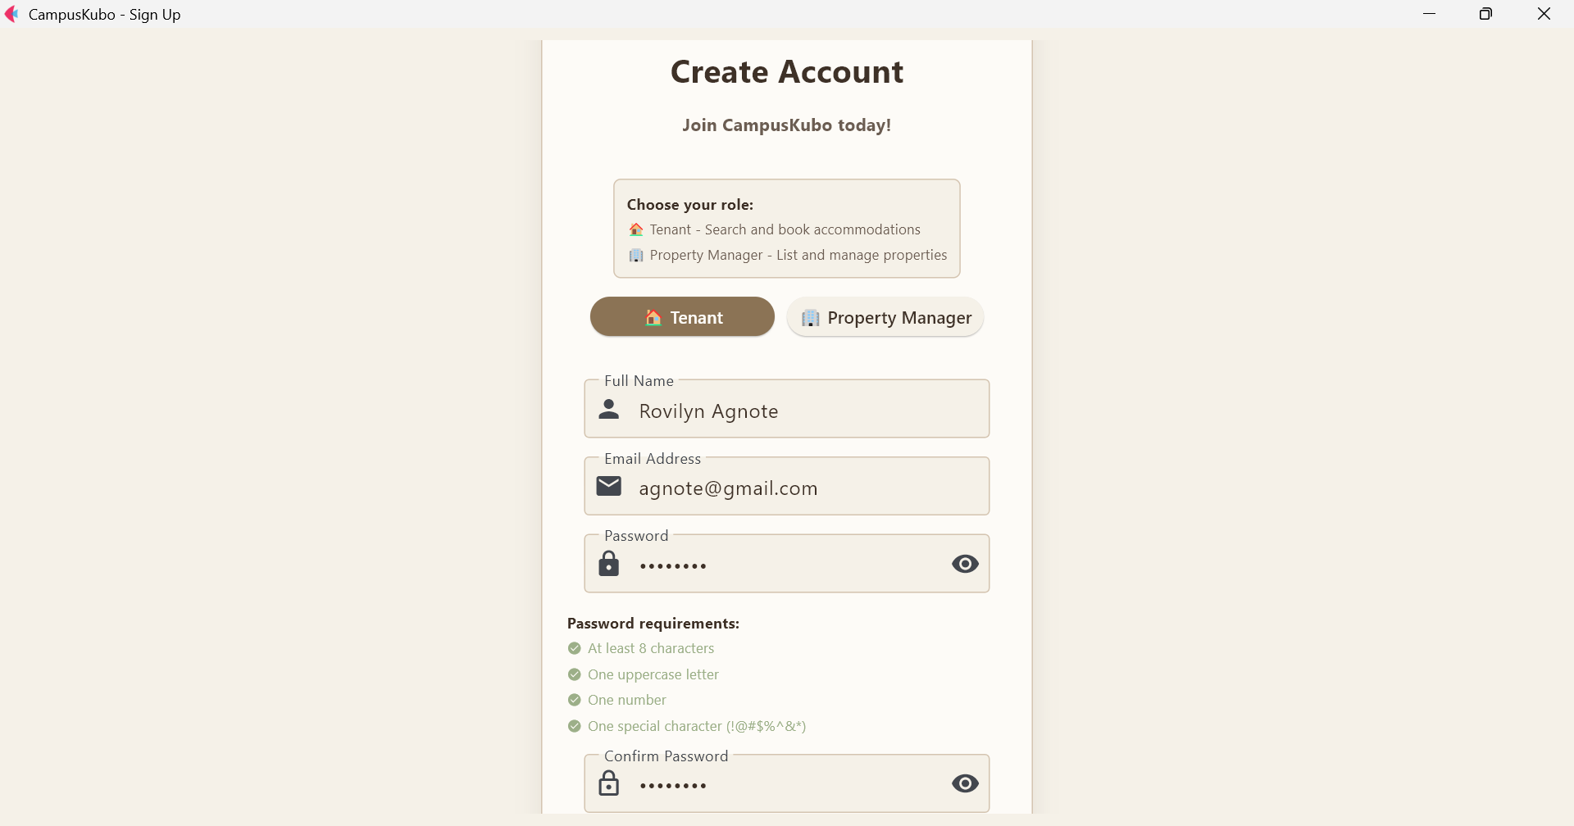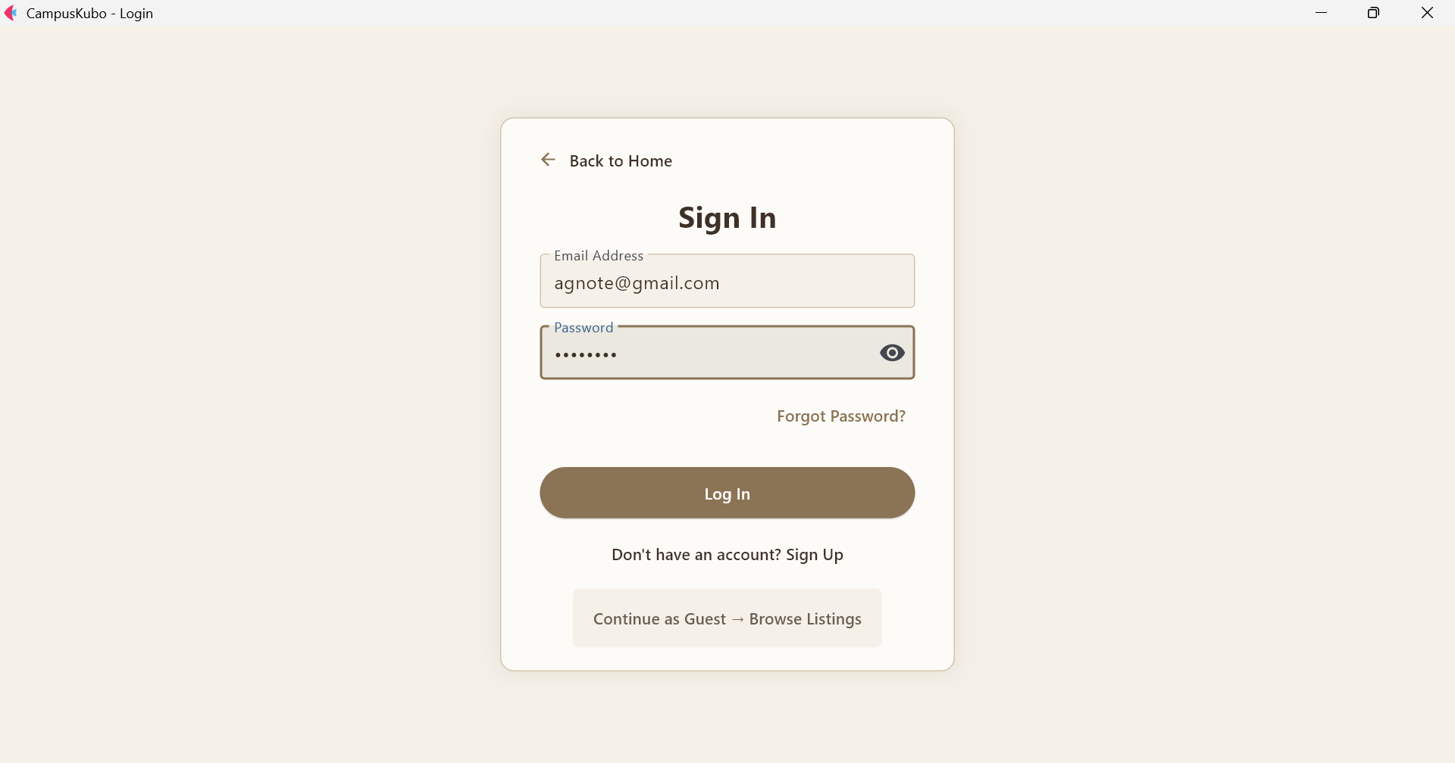

1. **Listings Pages (for browsing properties)**: Property listings with details, sign-up and log-in buttons, search filter sidebar

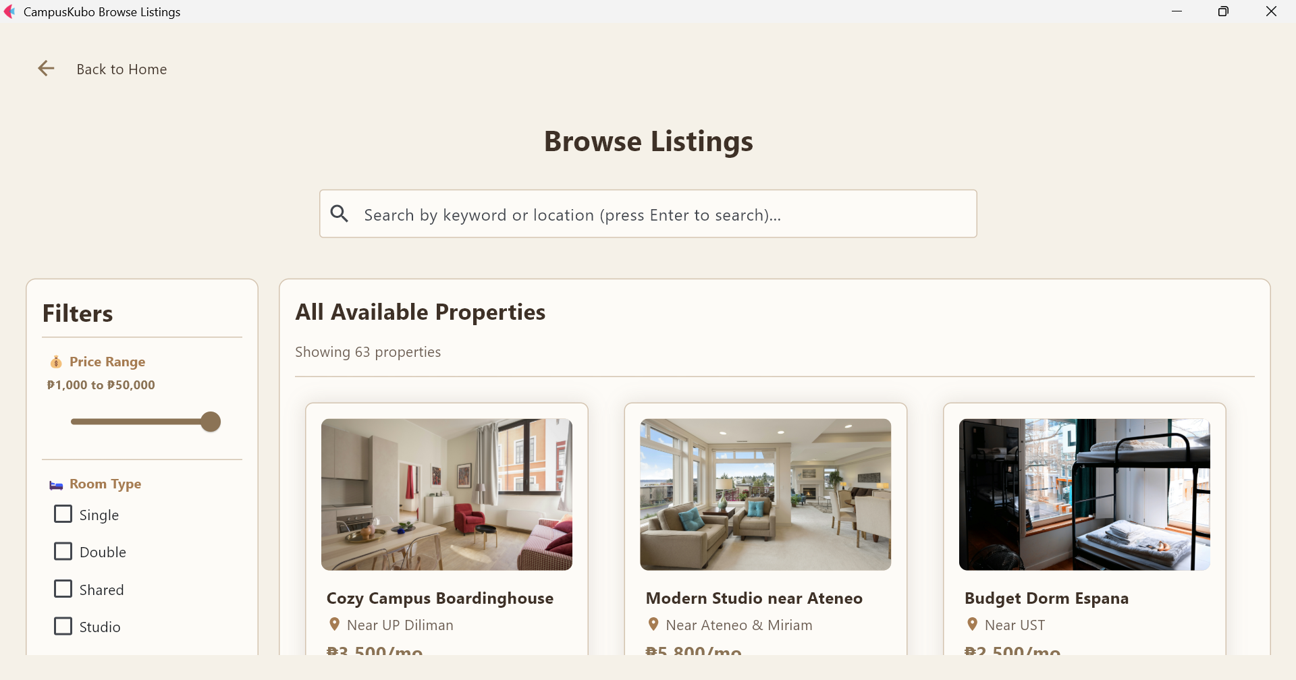

*Shows search bar, and list of available properties.*

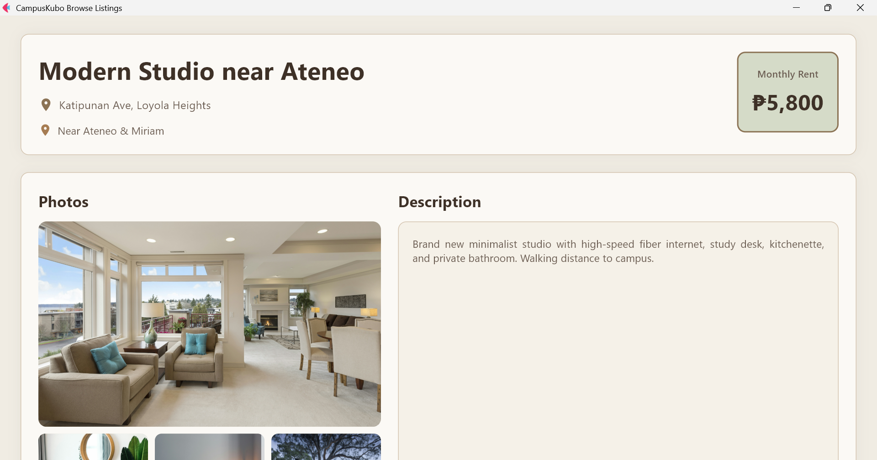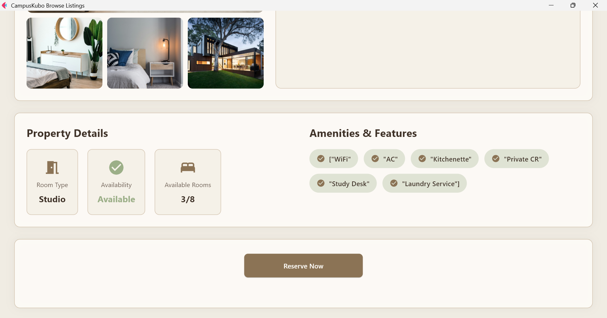

*Displays full listing info with photos, location, price, and description.*

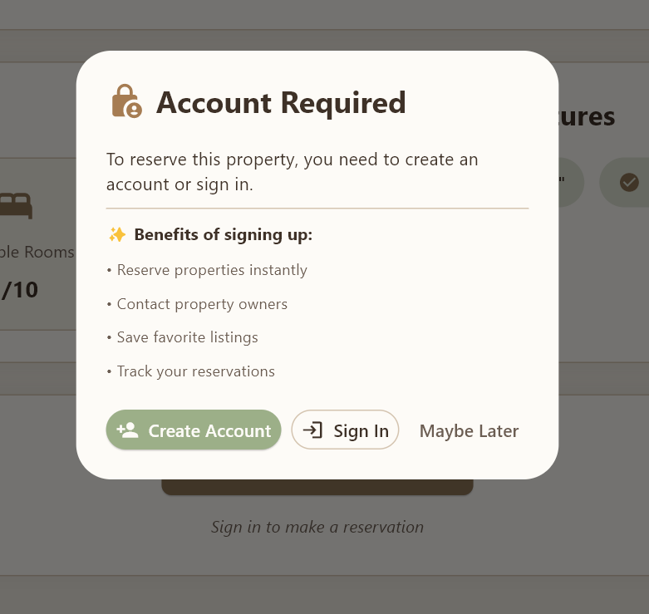

*Prompts users to sign up or log in to reserve properties.*

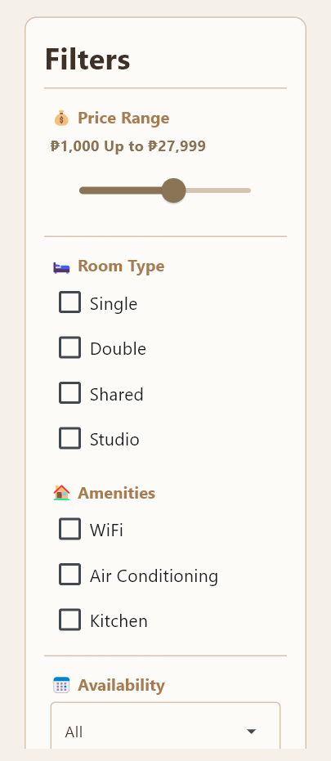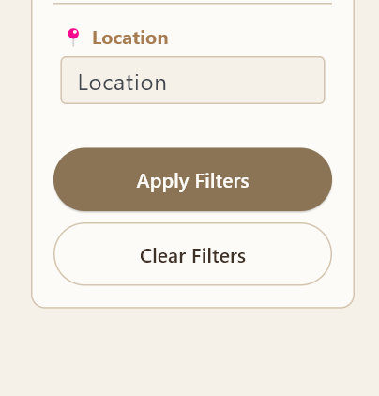

*Lets users filter by price, room type, amenities, availability and locations.*

1. **Admin Dashboard**: Key metrics (users, active listings, reservations), quick actions.

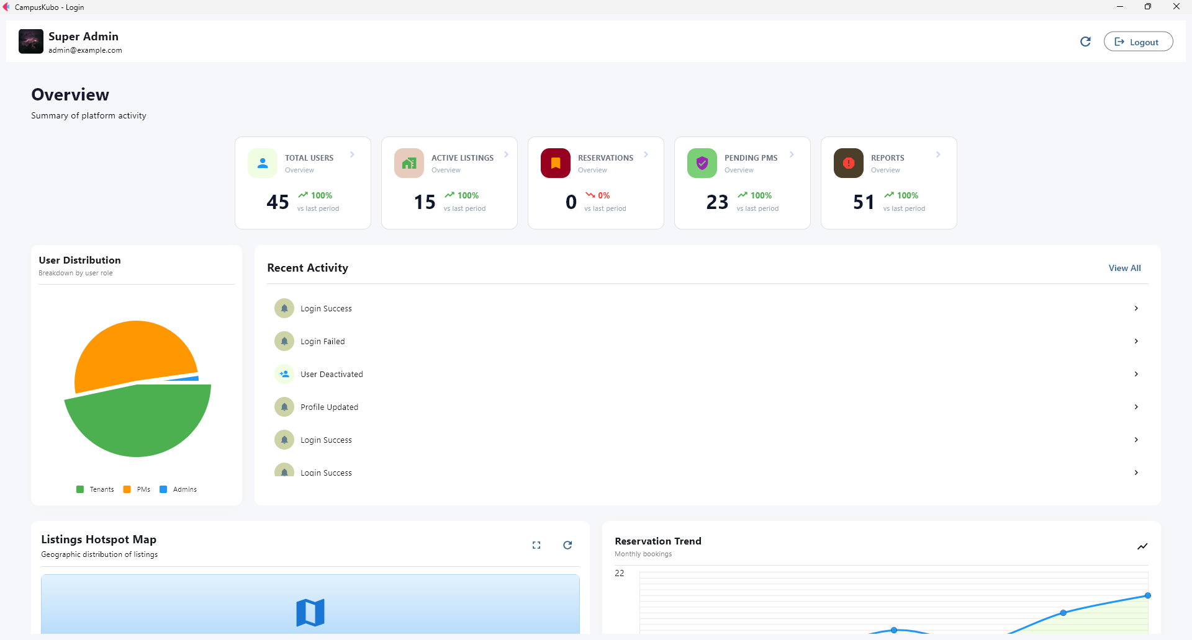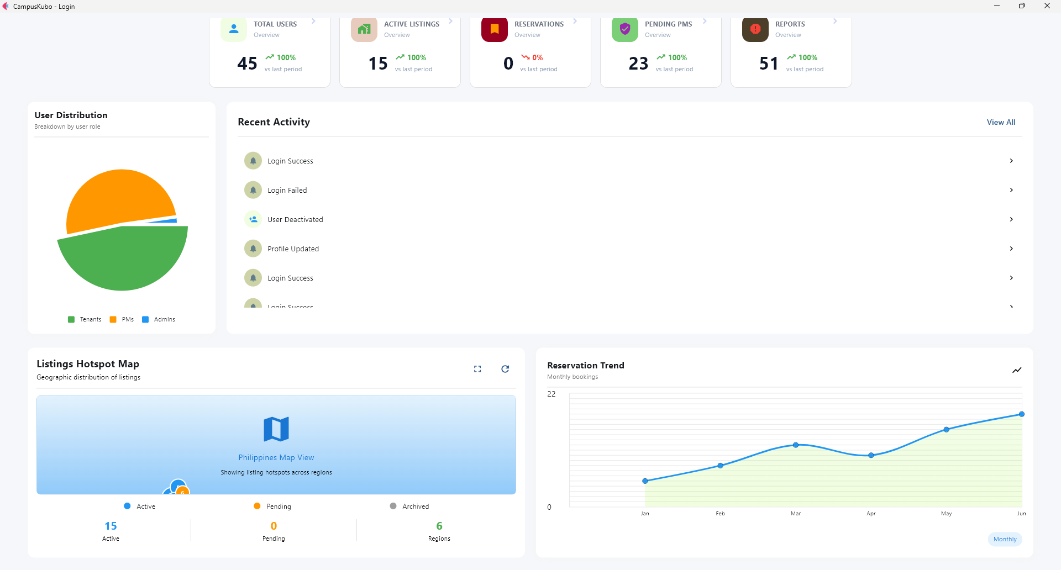

*Main Dashboard View*

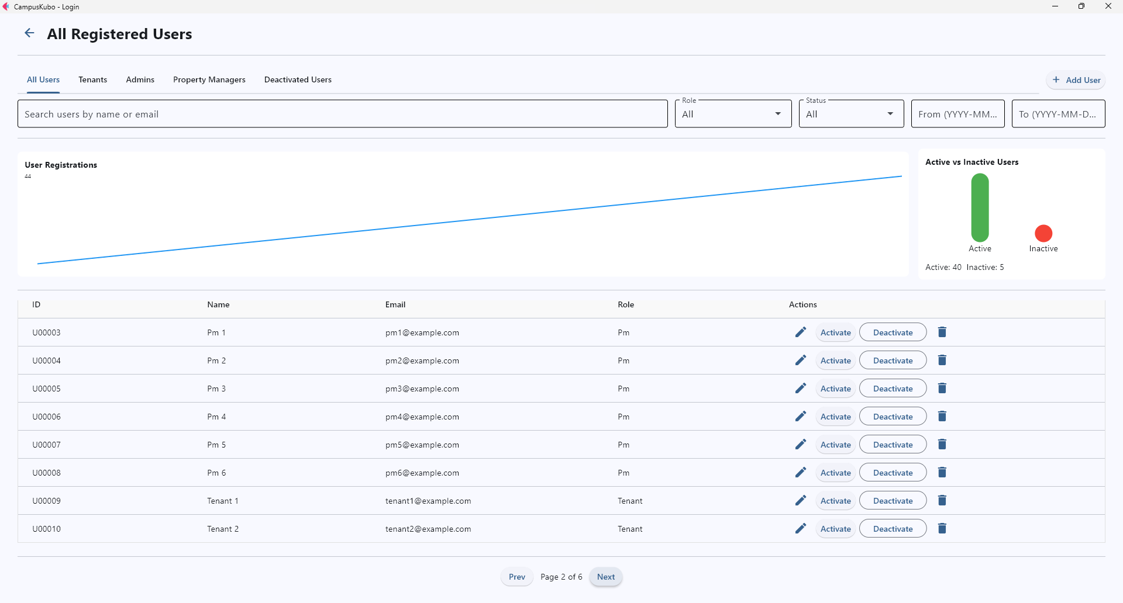

*User Management Page*

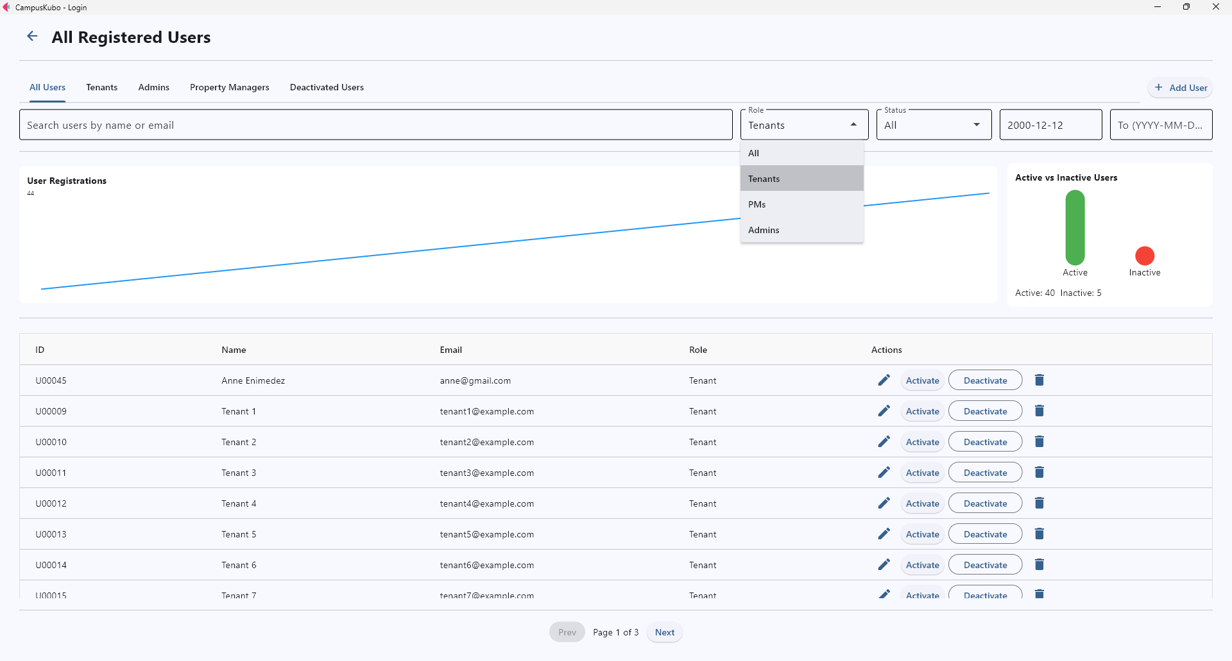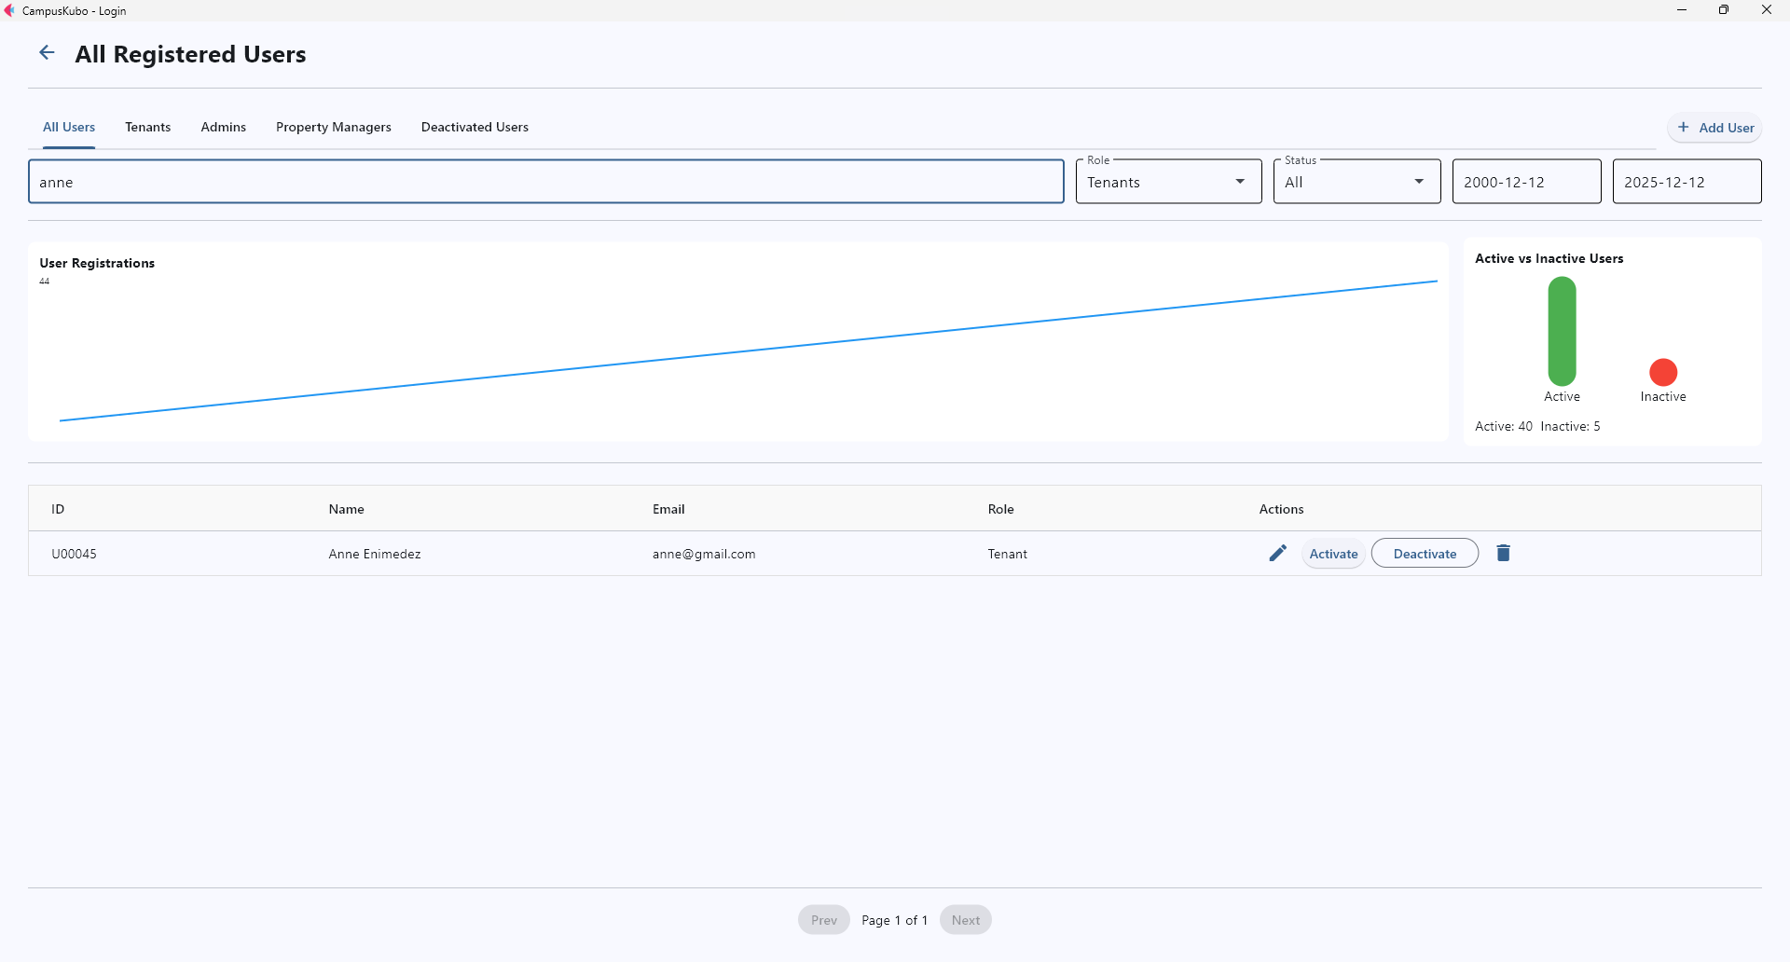*Active Search Filters*

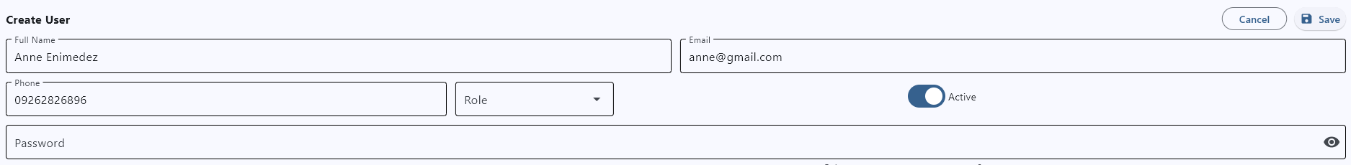

*Create/Edit User Info Form*

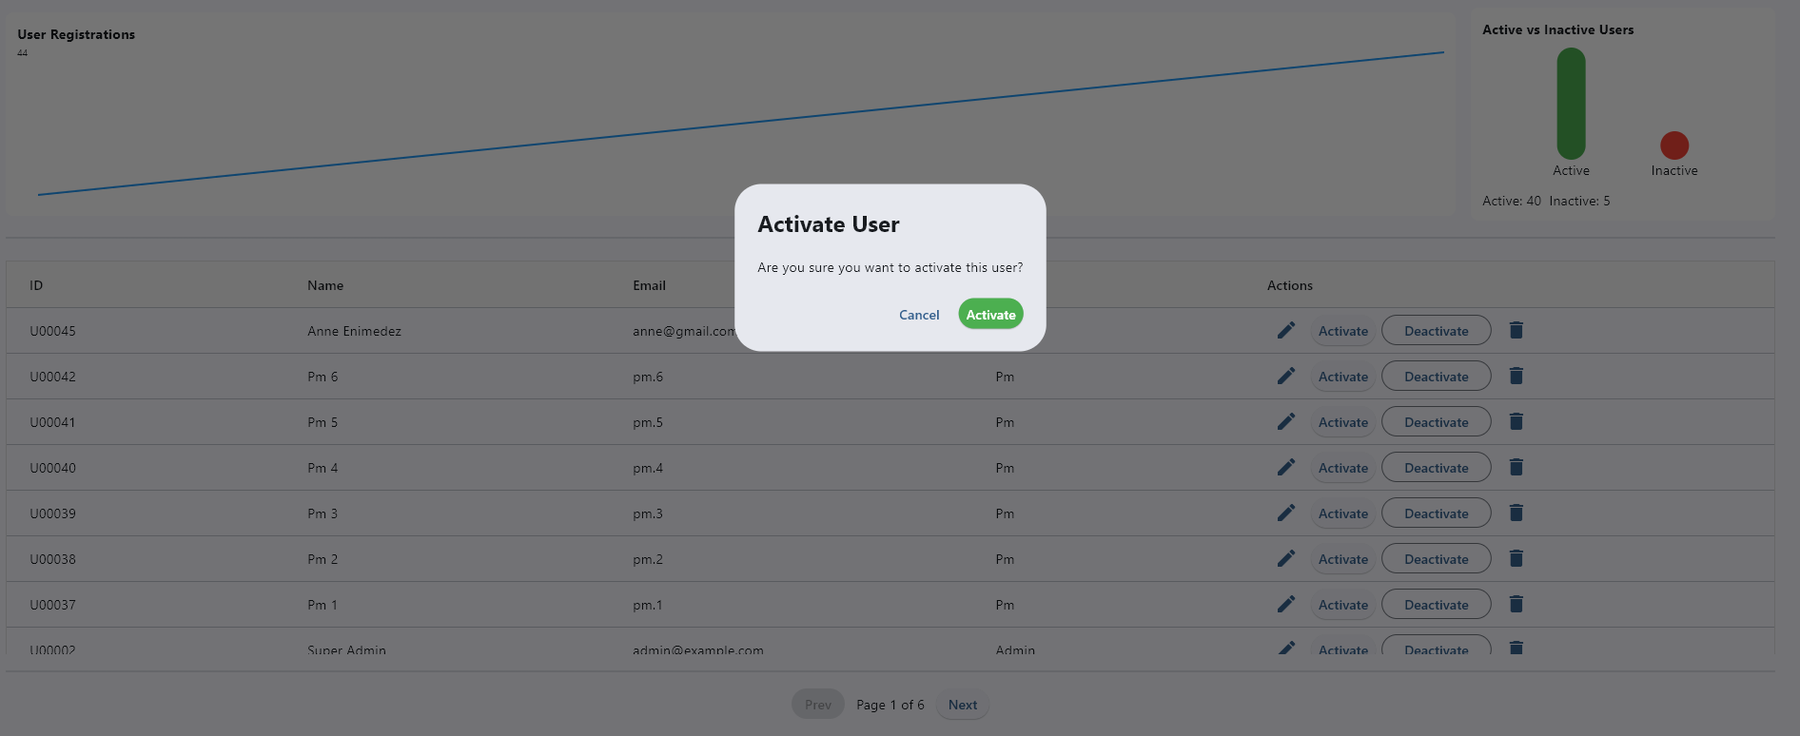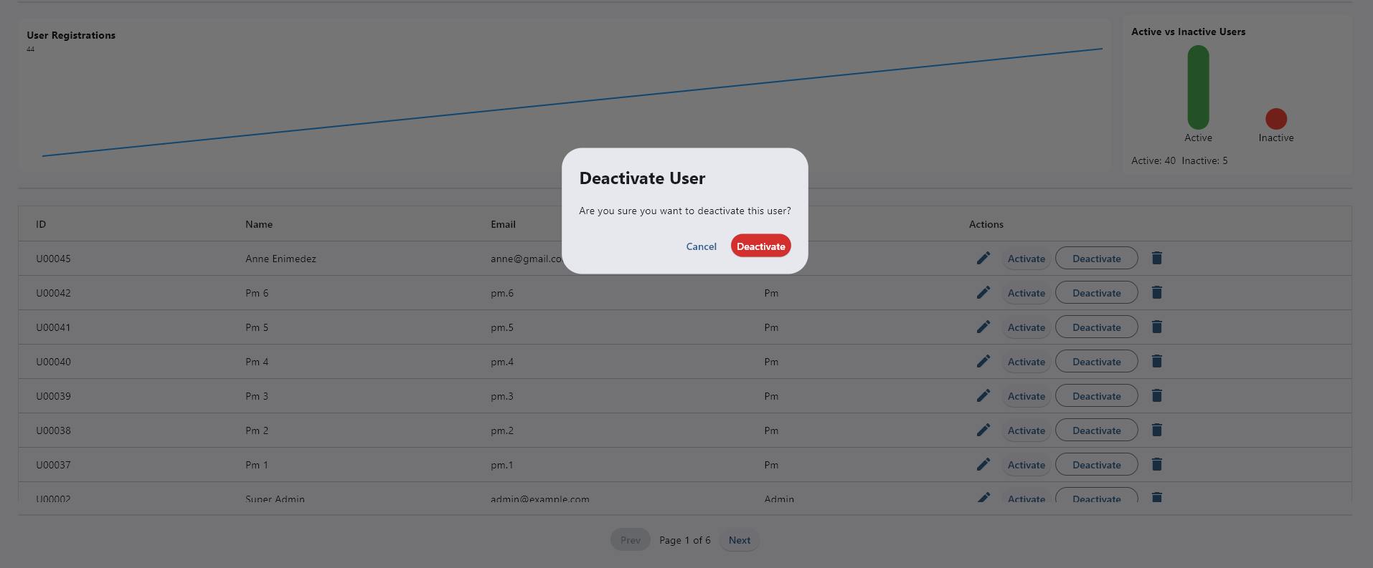

*Activation and Deactivation of User*

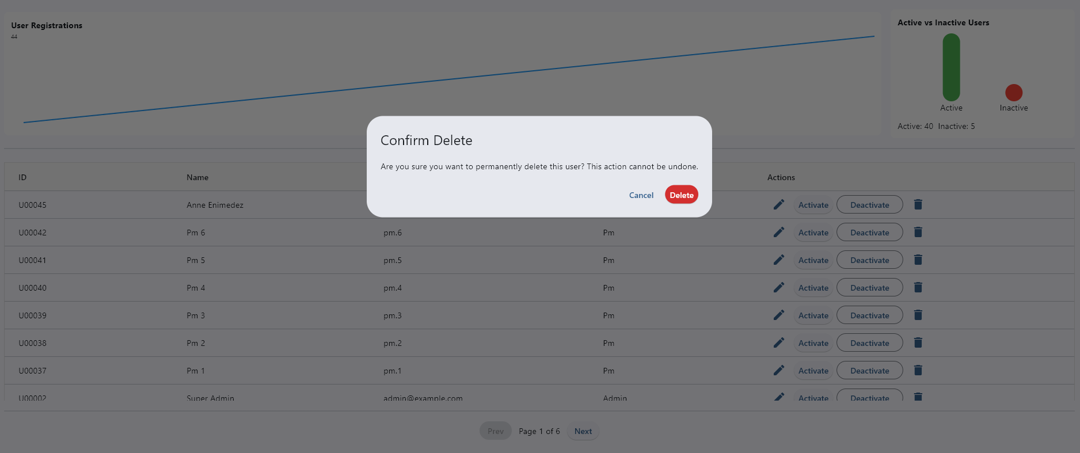

*Deletion of User*

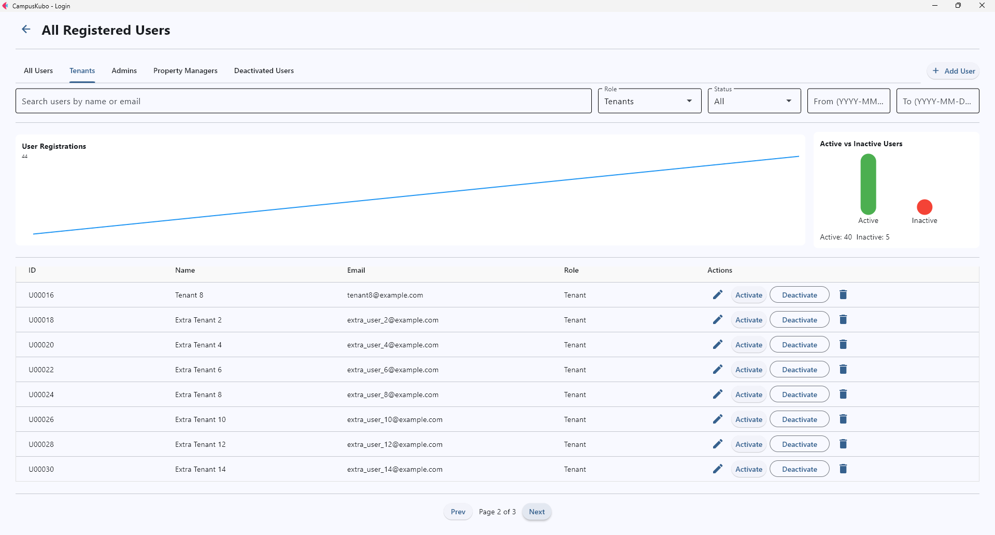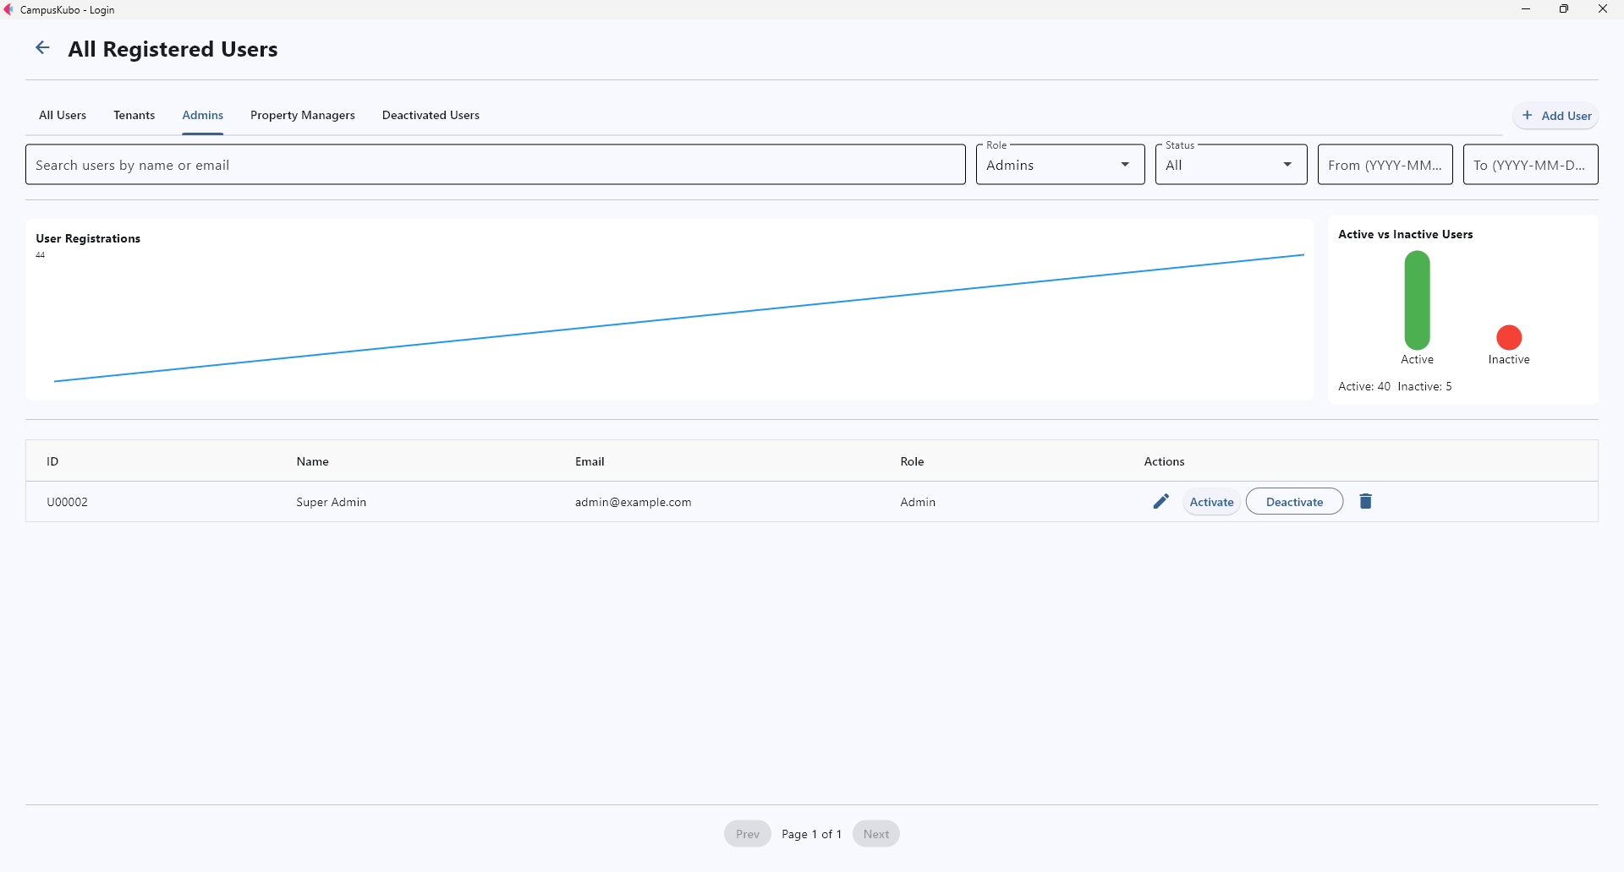

*Tenants Tab Admins Tab*

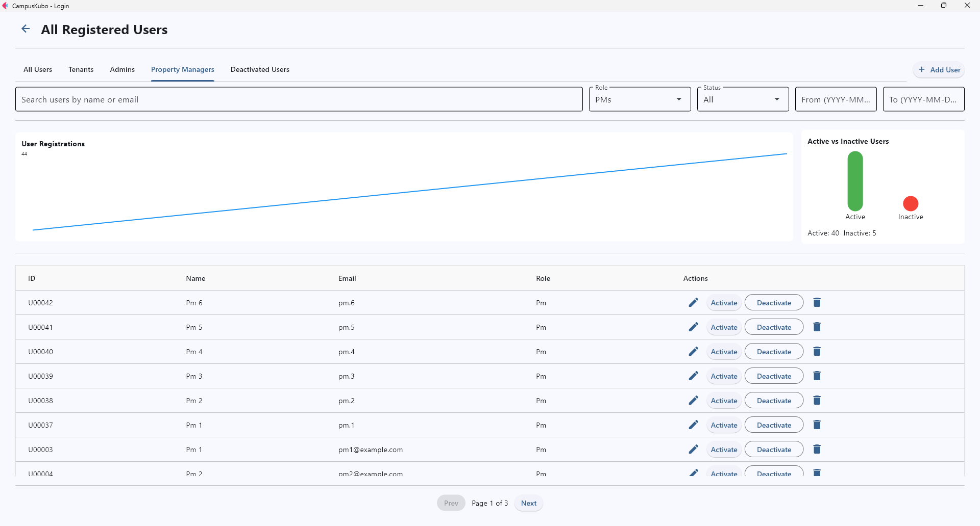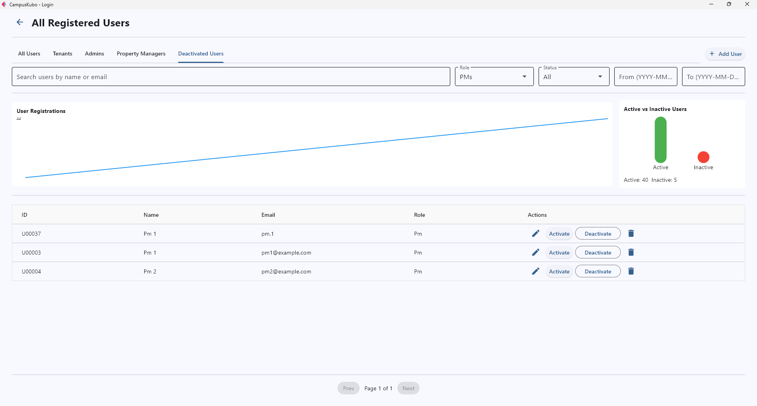

*PMs Tab Deactivated Users Tab*

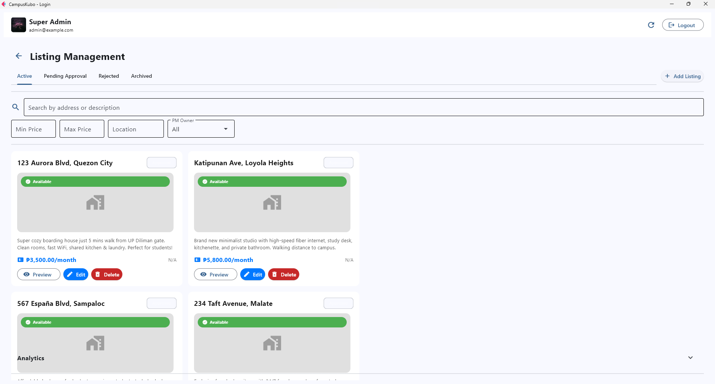

*Listing Management Page*

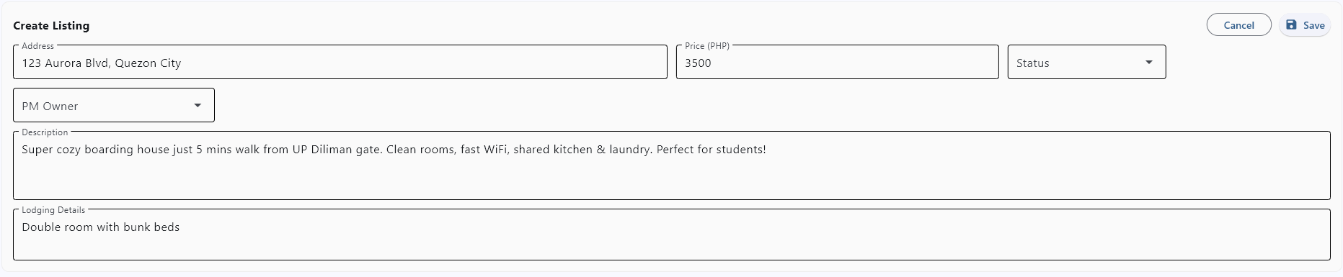

*Create/Edit Listing Form*

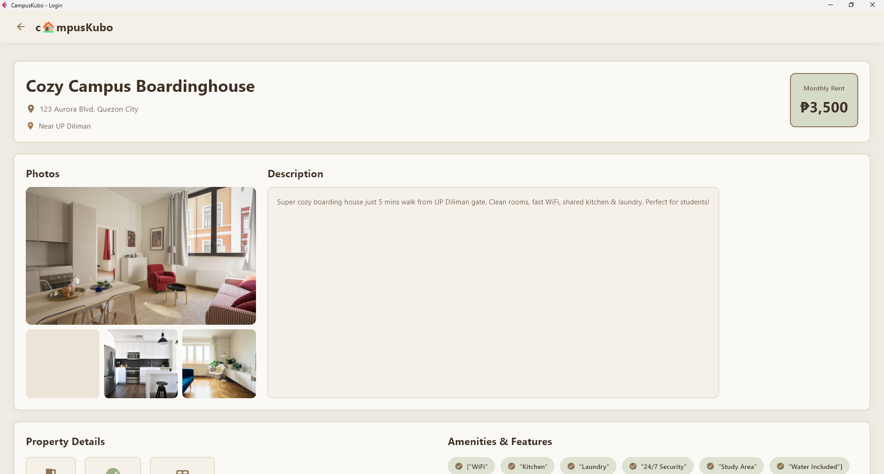

*Preview Property Page*

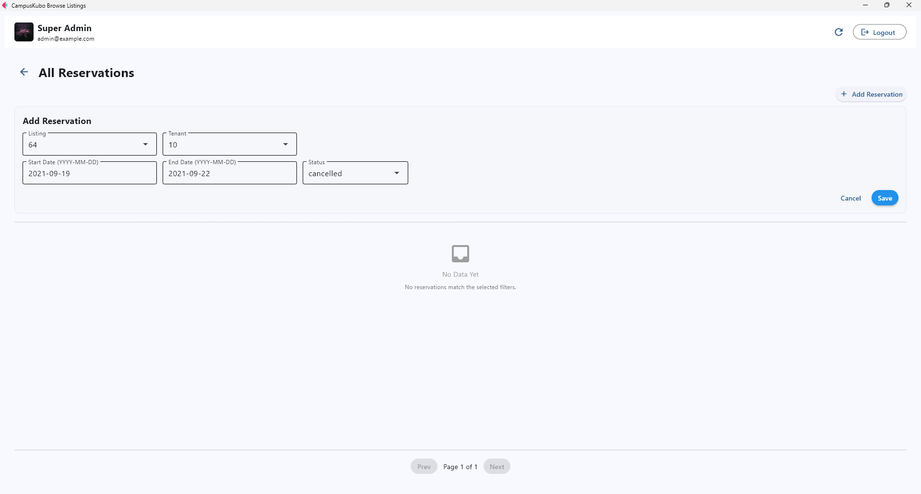

*Reservations Page with Add Reservation Feature*

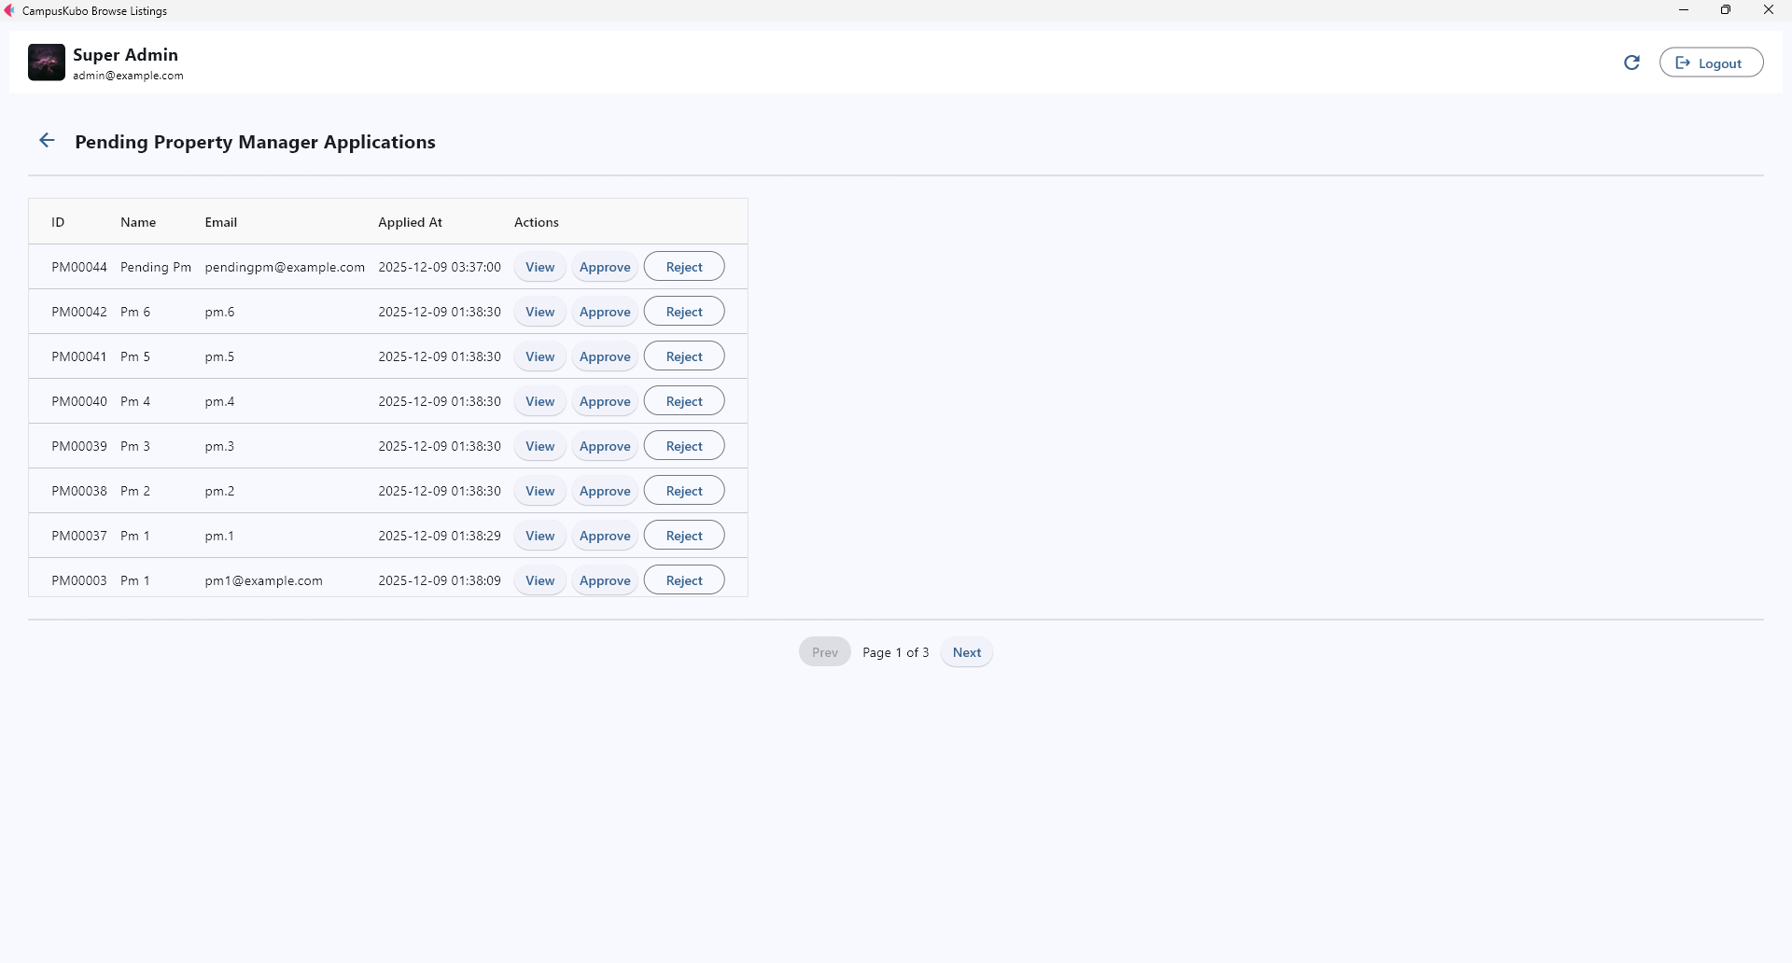

*Pending PM Applications Page*

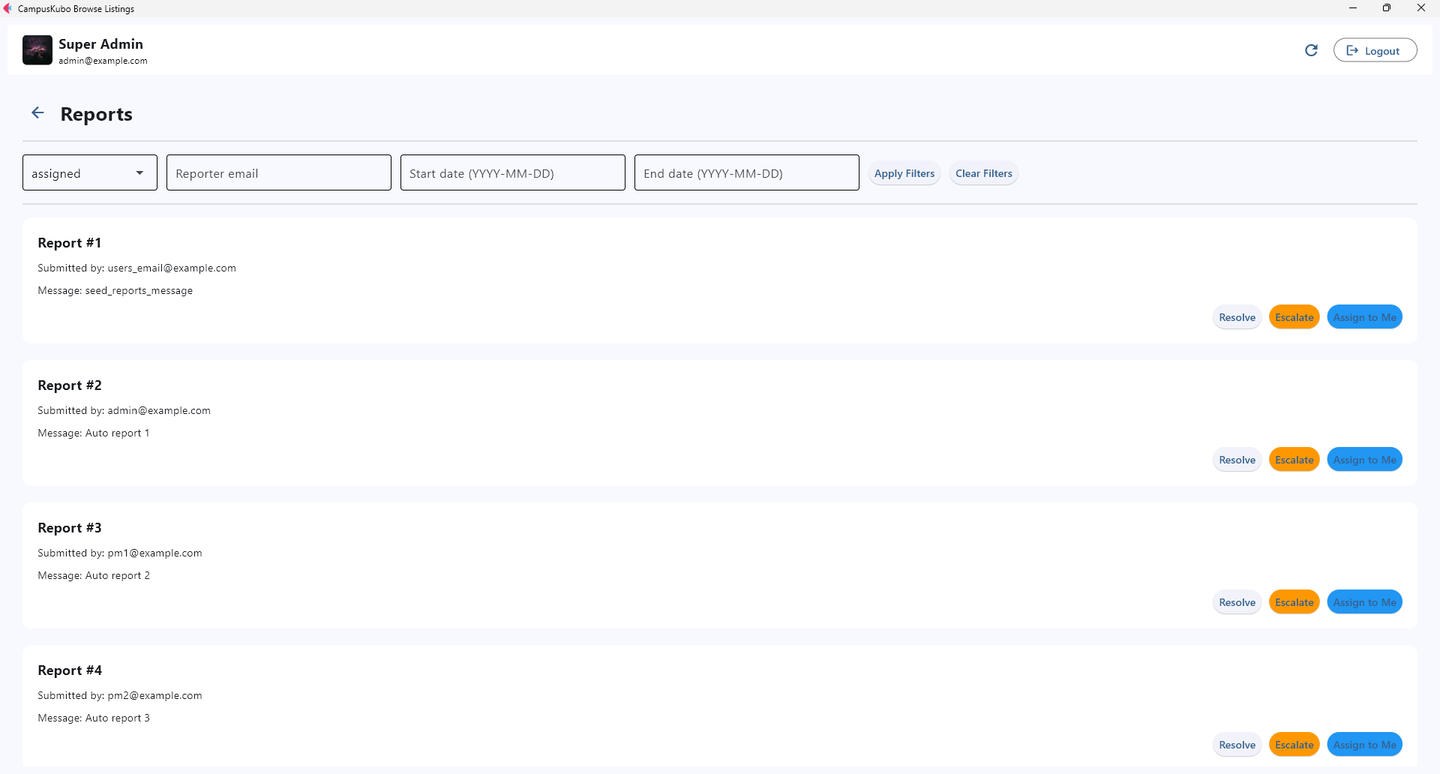

*Reports Page with Active Search Filter*

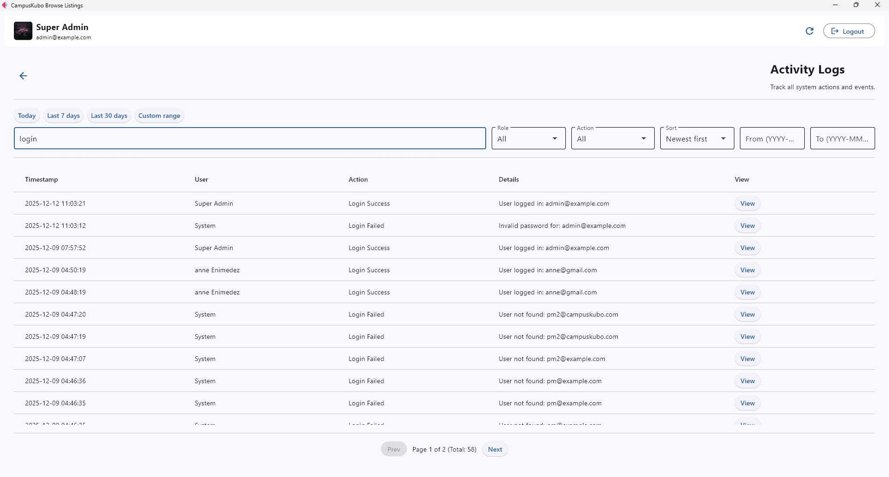

*Activity Logs Page with Active Search Filter*

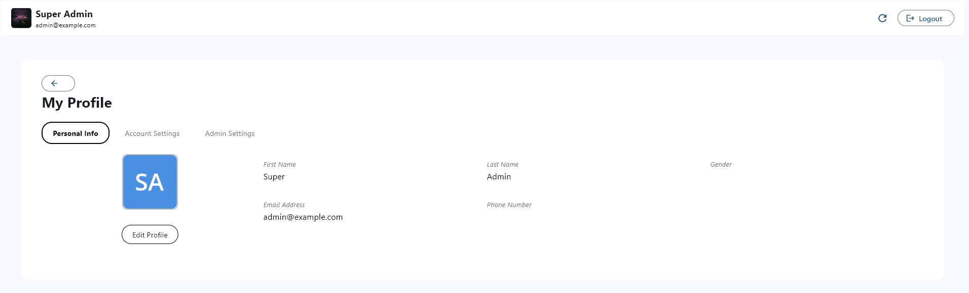

*Admin Profile Page*

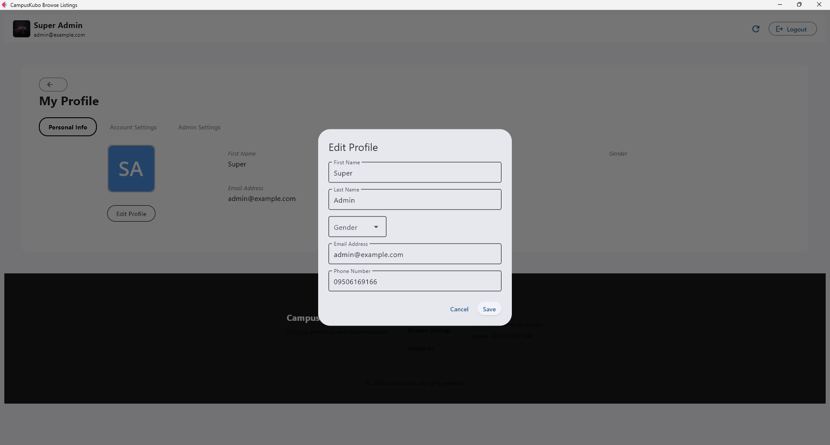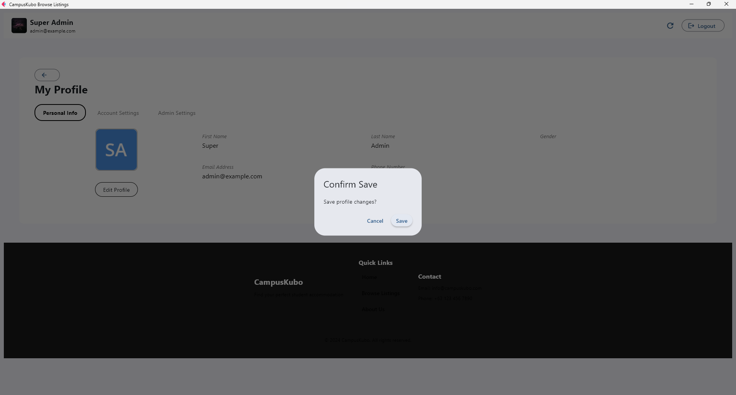 *Personal Info Tab with Edit Form and Confirmation Dialog*

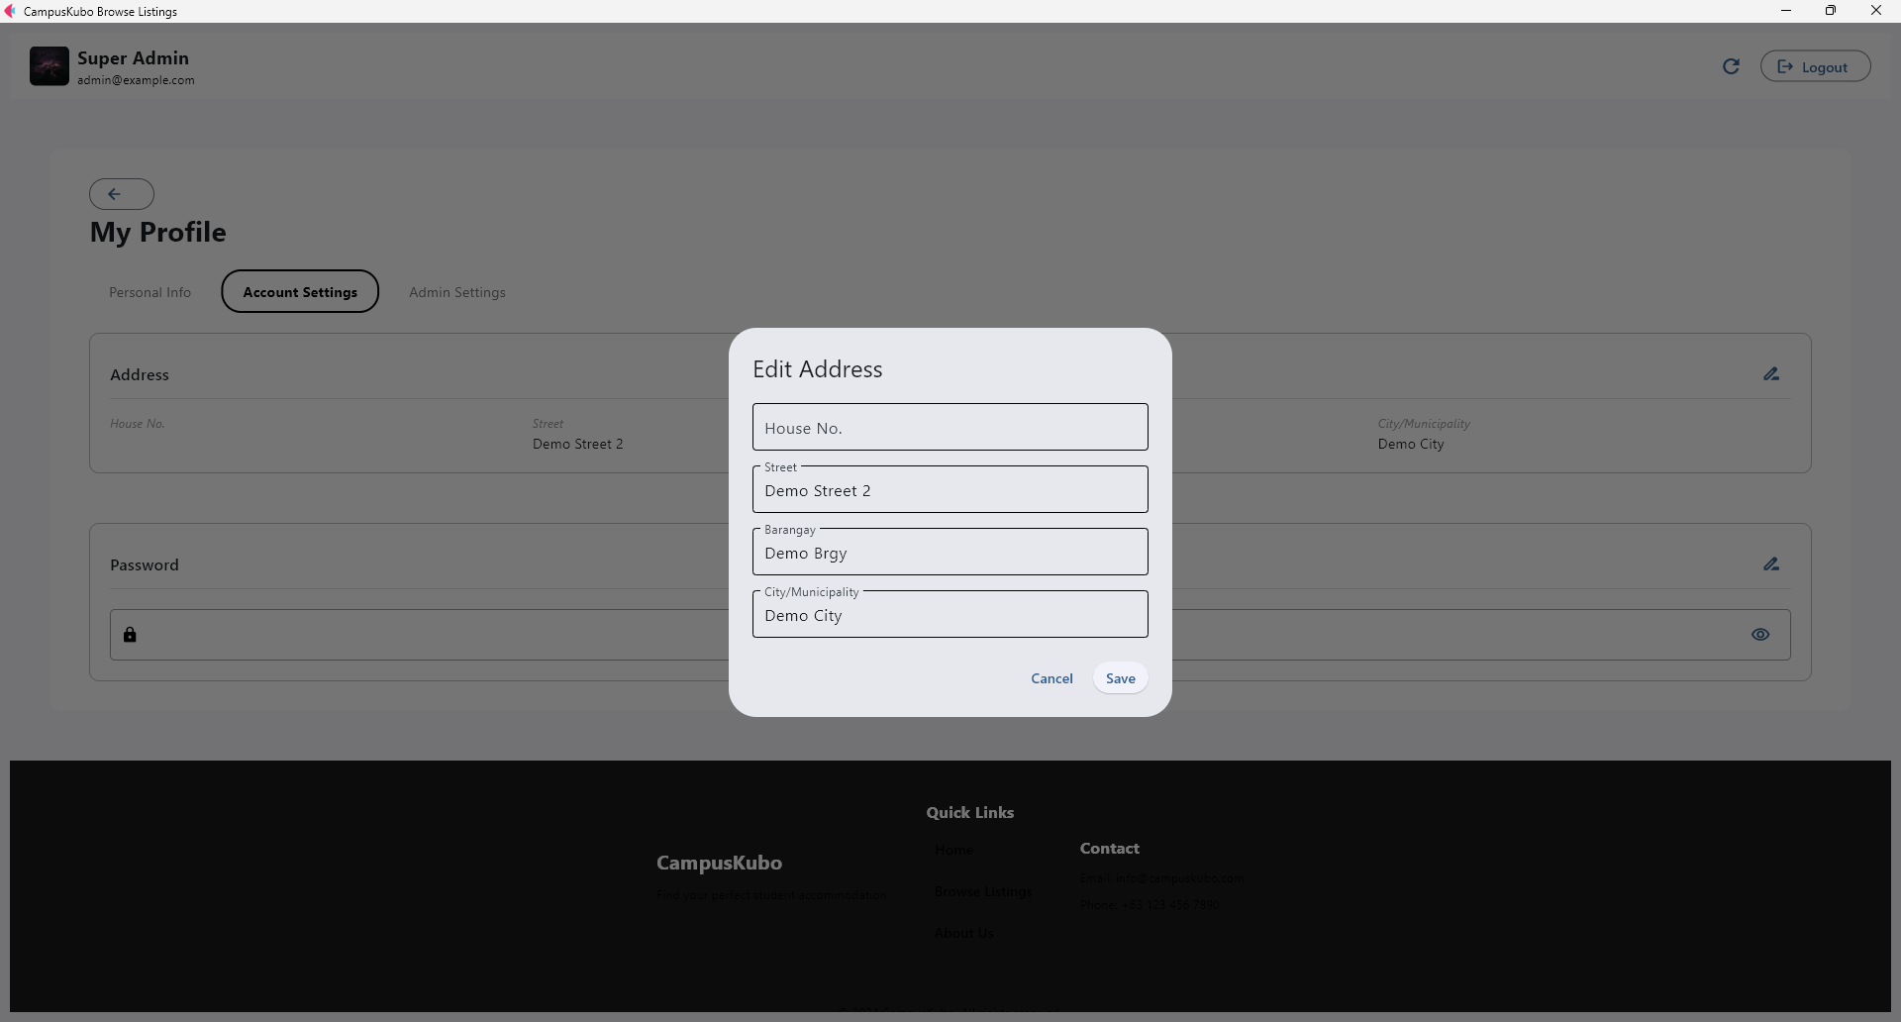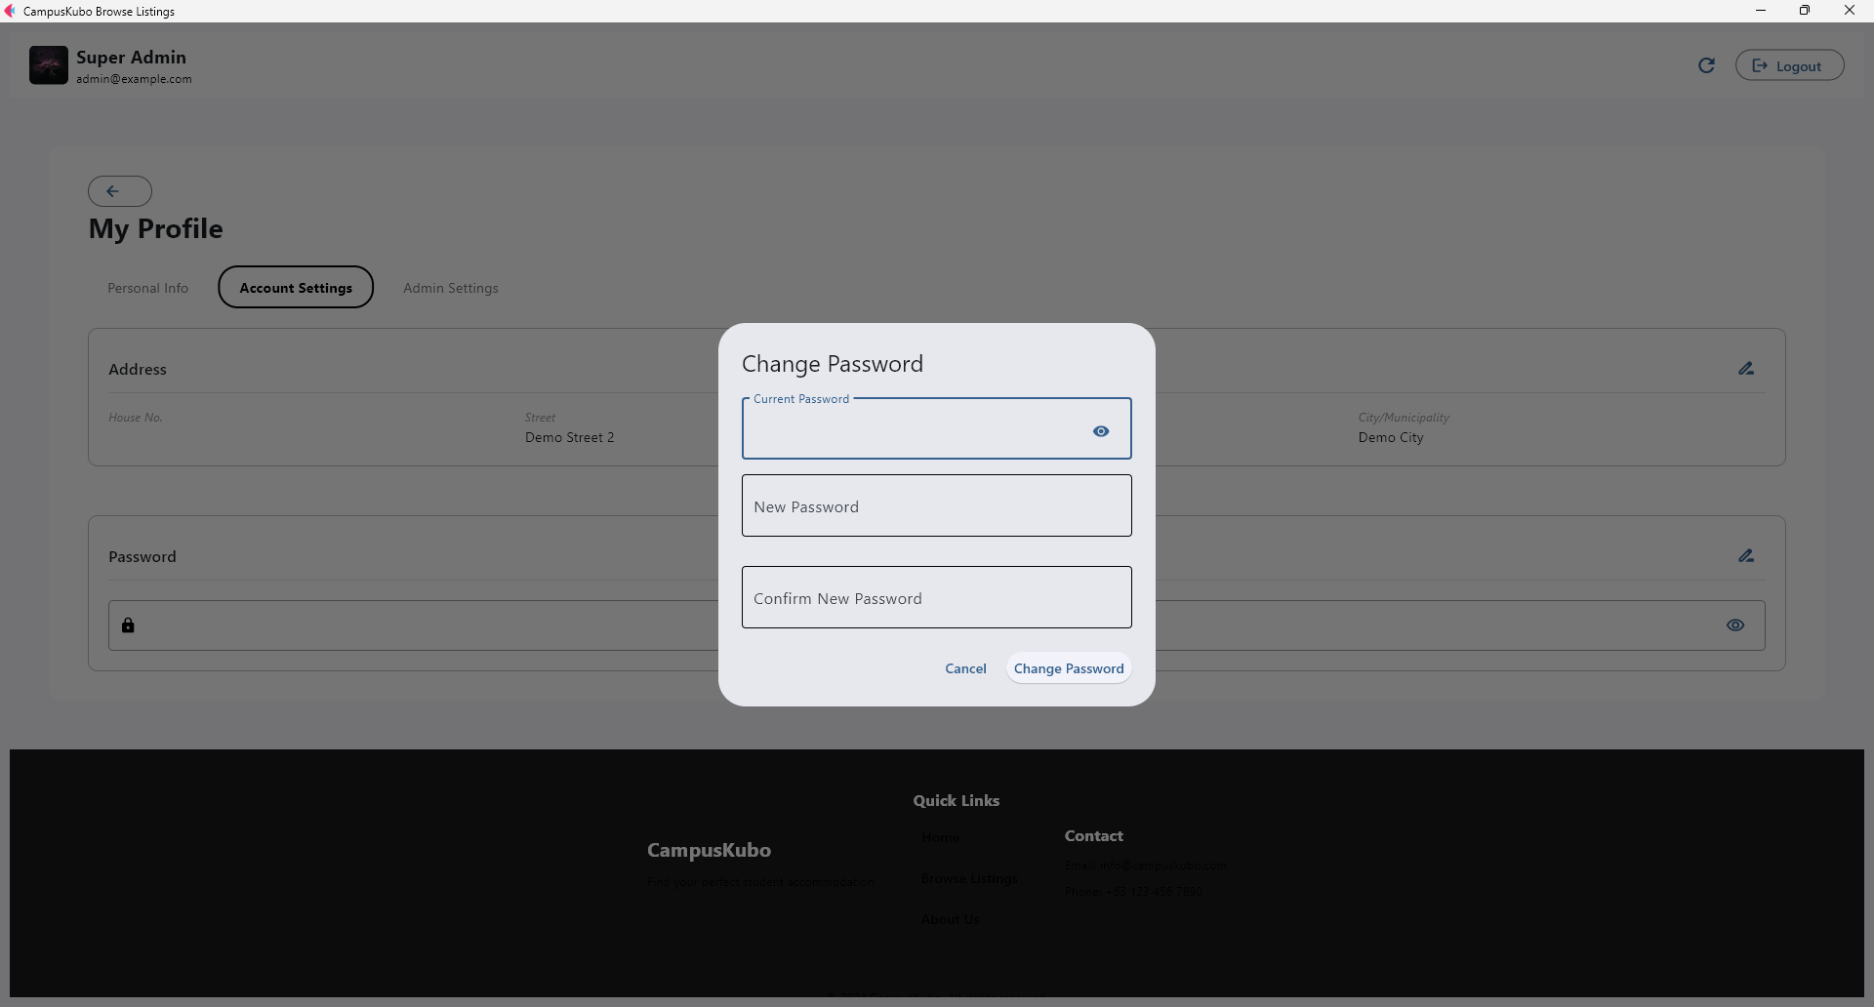

*Accounts Settings Tab with Edit Address and Change Password Forms*

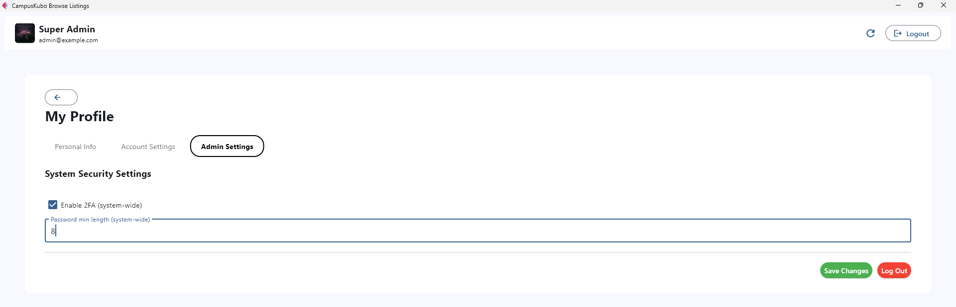

*Admin Settings Tab*

1. **Property Manager Dashboard**: Images carousel, description, amenities, reserve button.

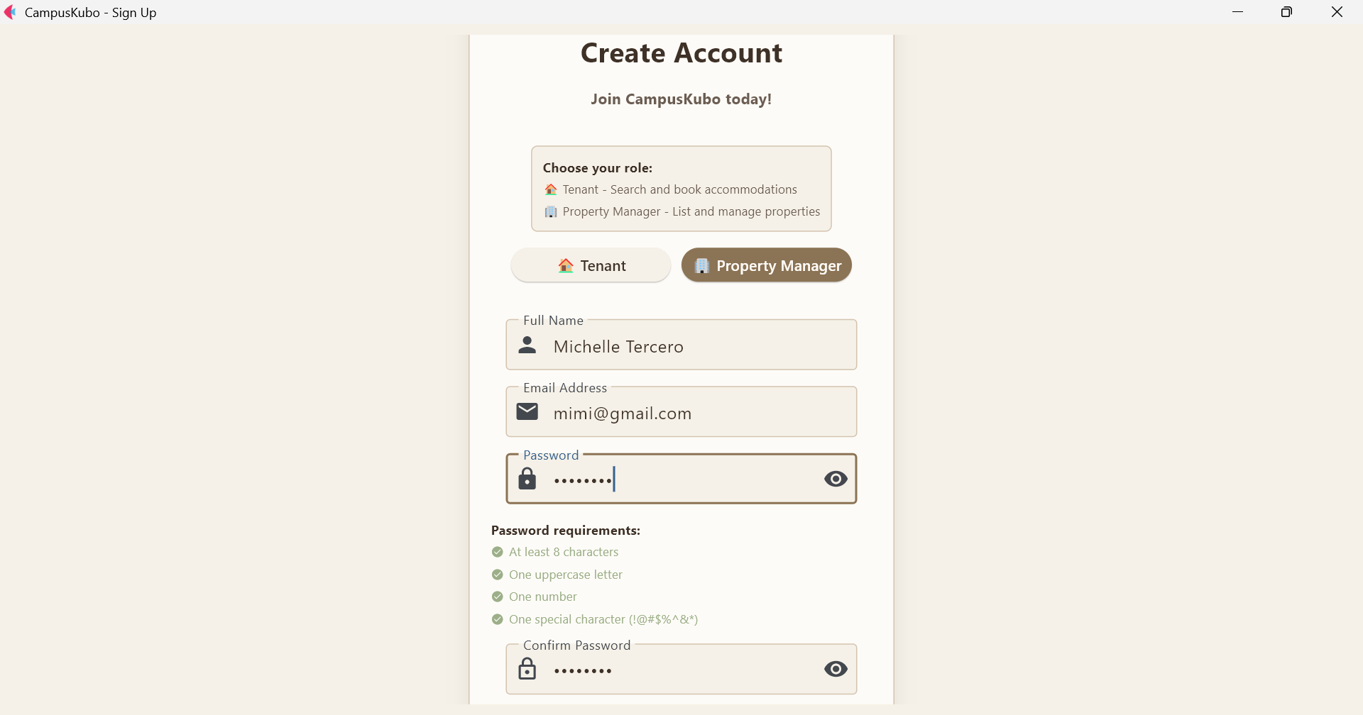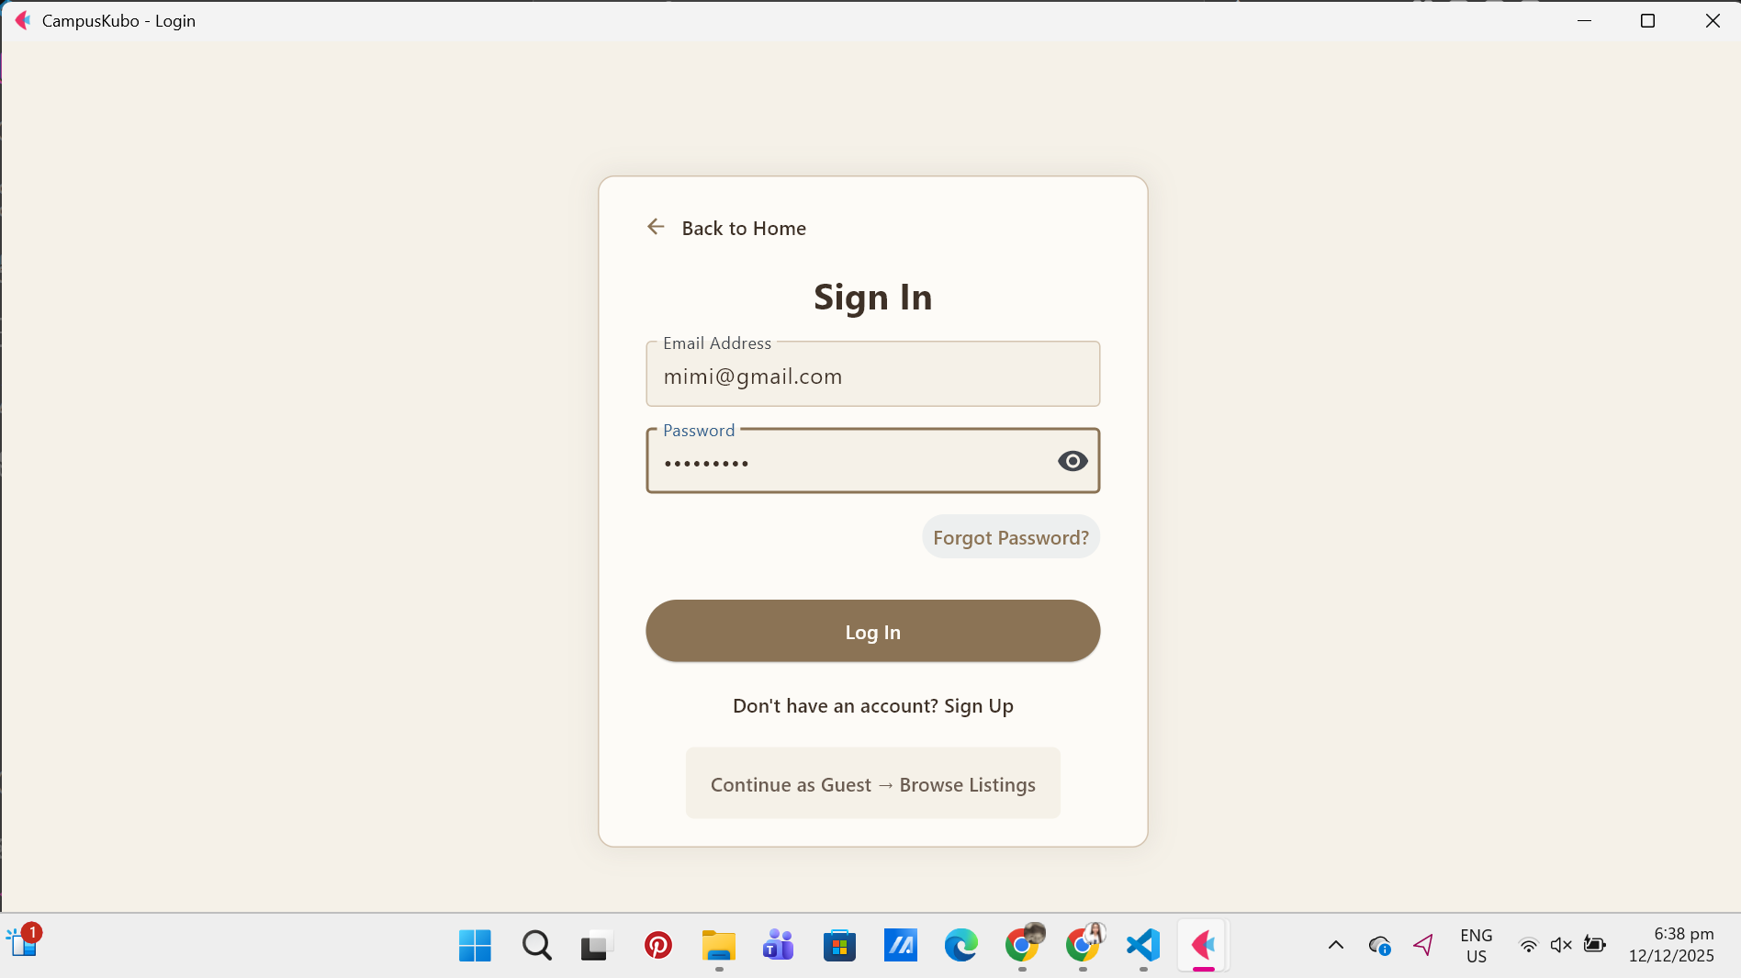

*Sign up Login*

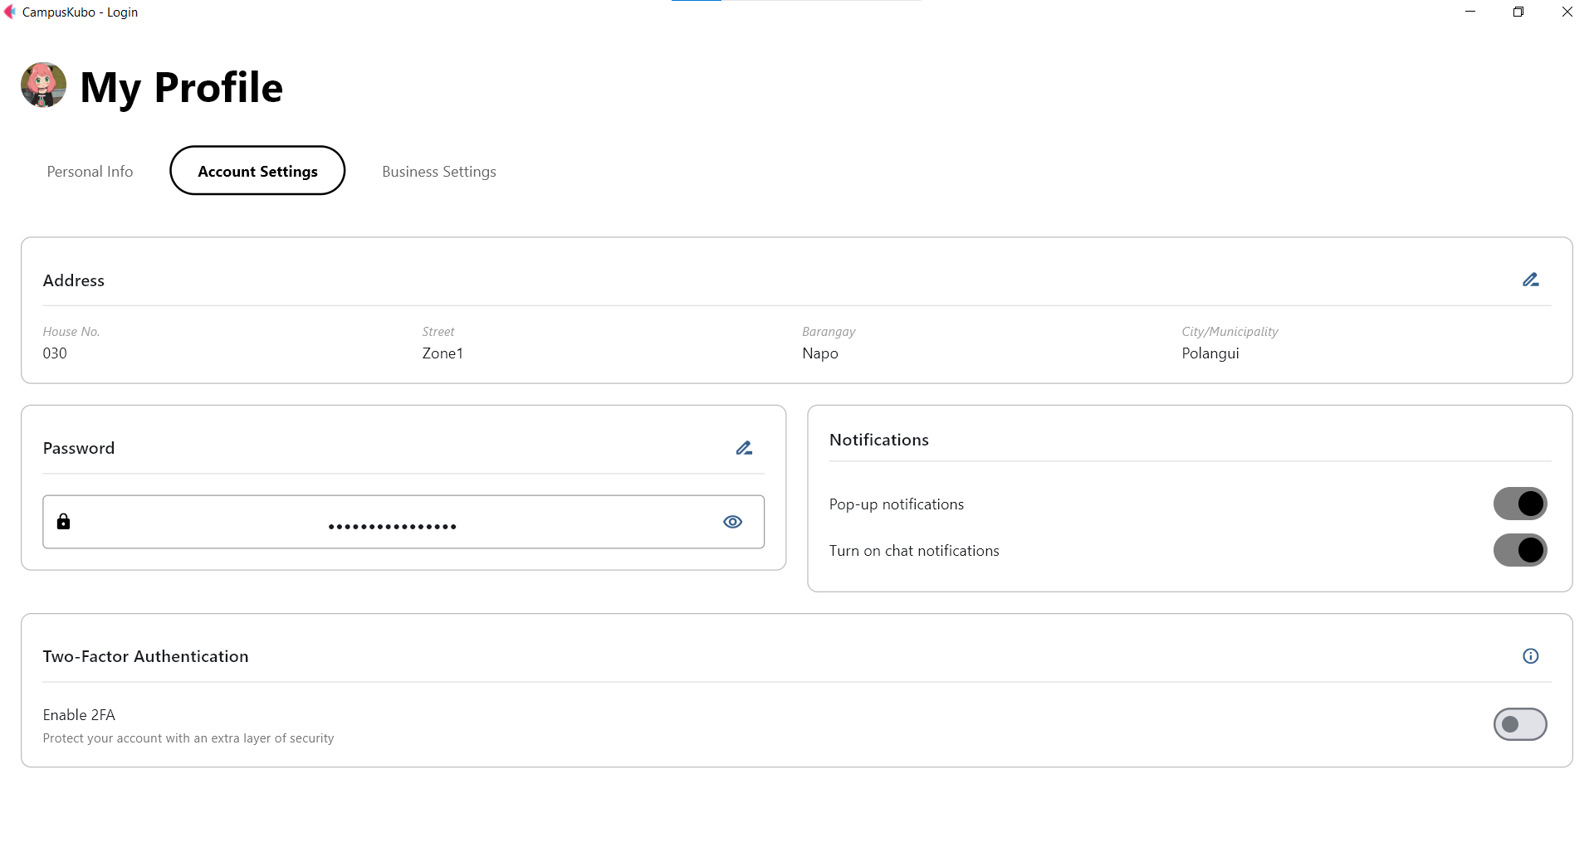

*PM - Account settings*

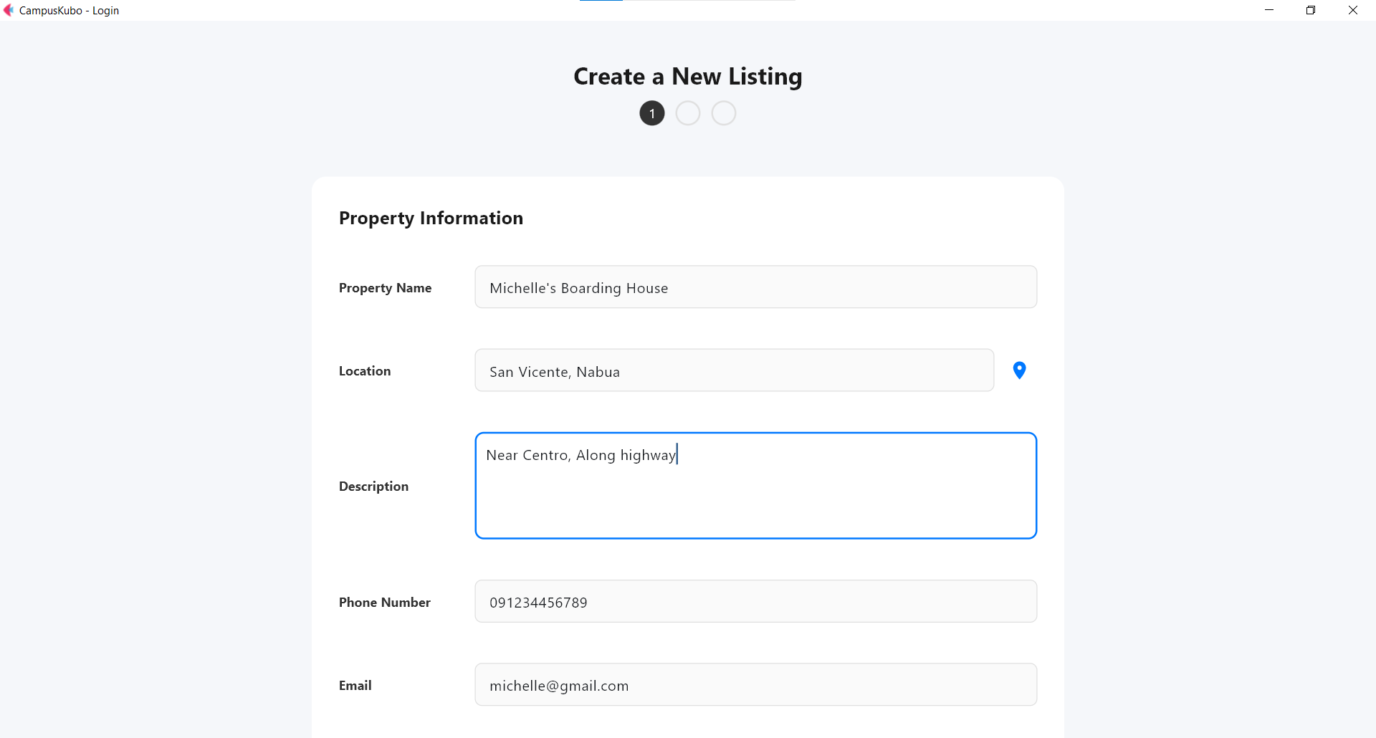

*Adding a new property listing, showing basic property information fields.*

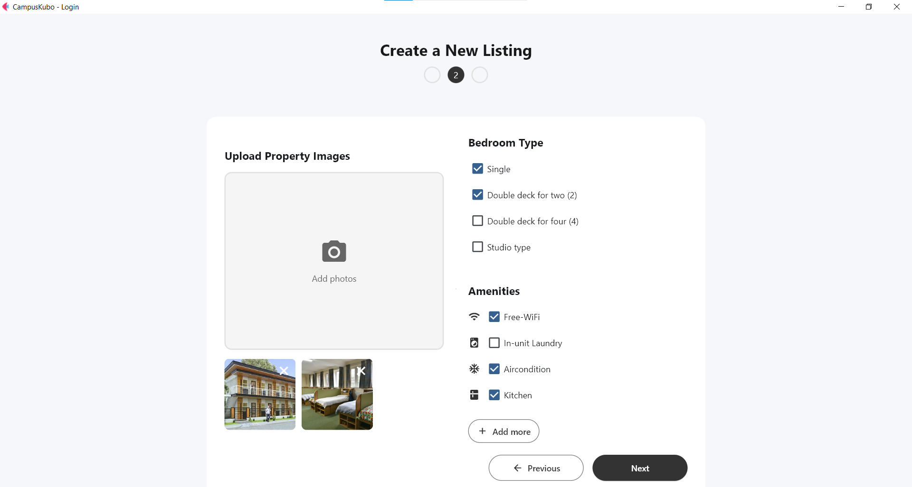

*Allowing users to input additional property details.*

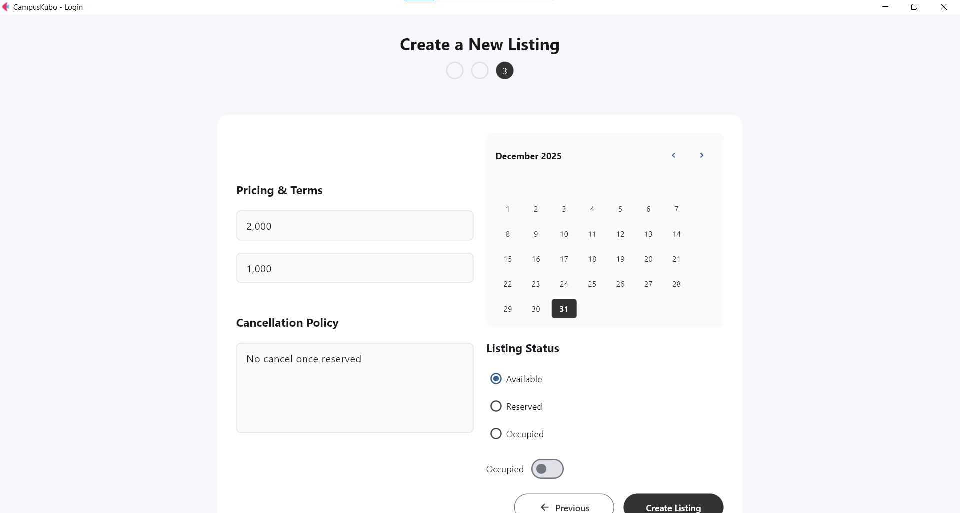

*Confirmation and summary of entered details.*

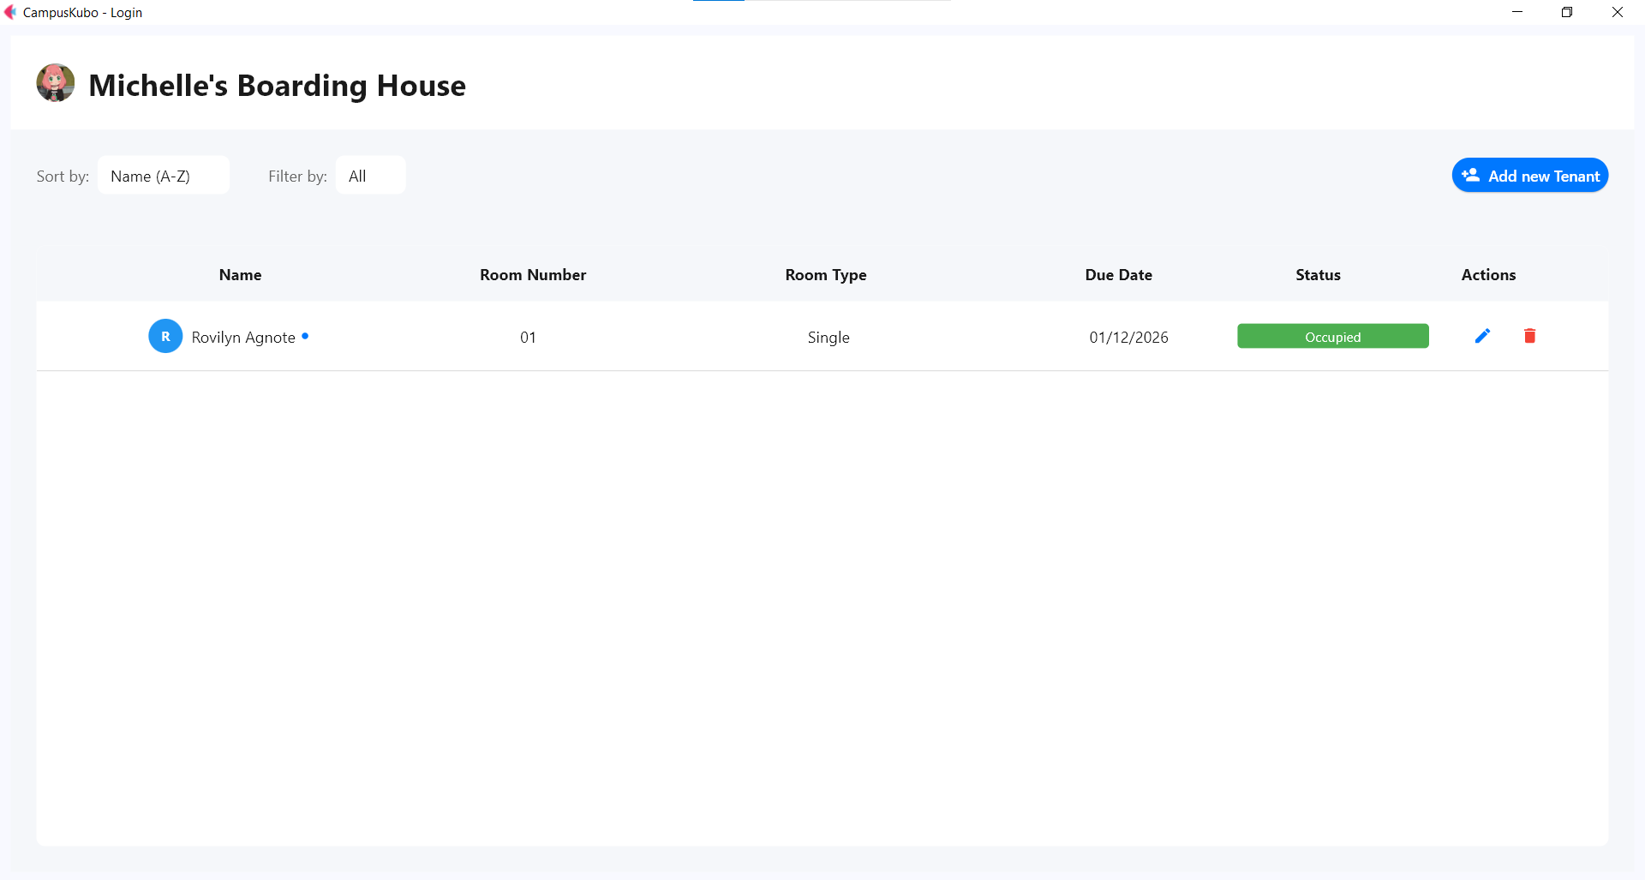

*Interface for adding a tenant to a selected property.*

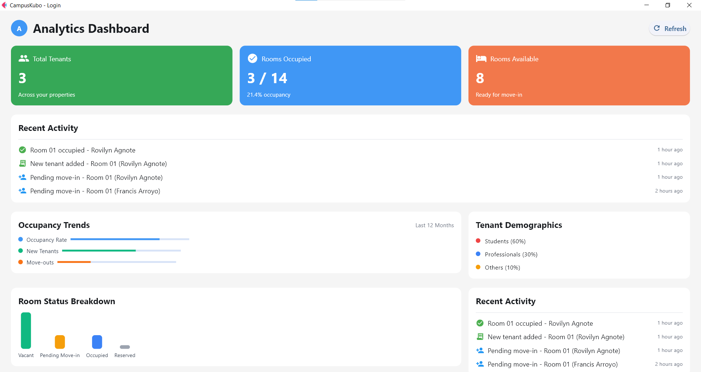

*Overview page showing summarized data for all properties managed by the user.*

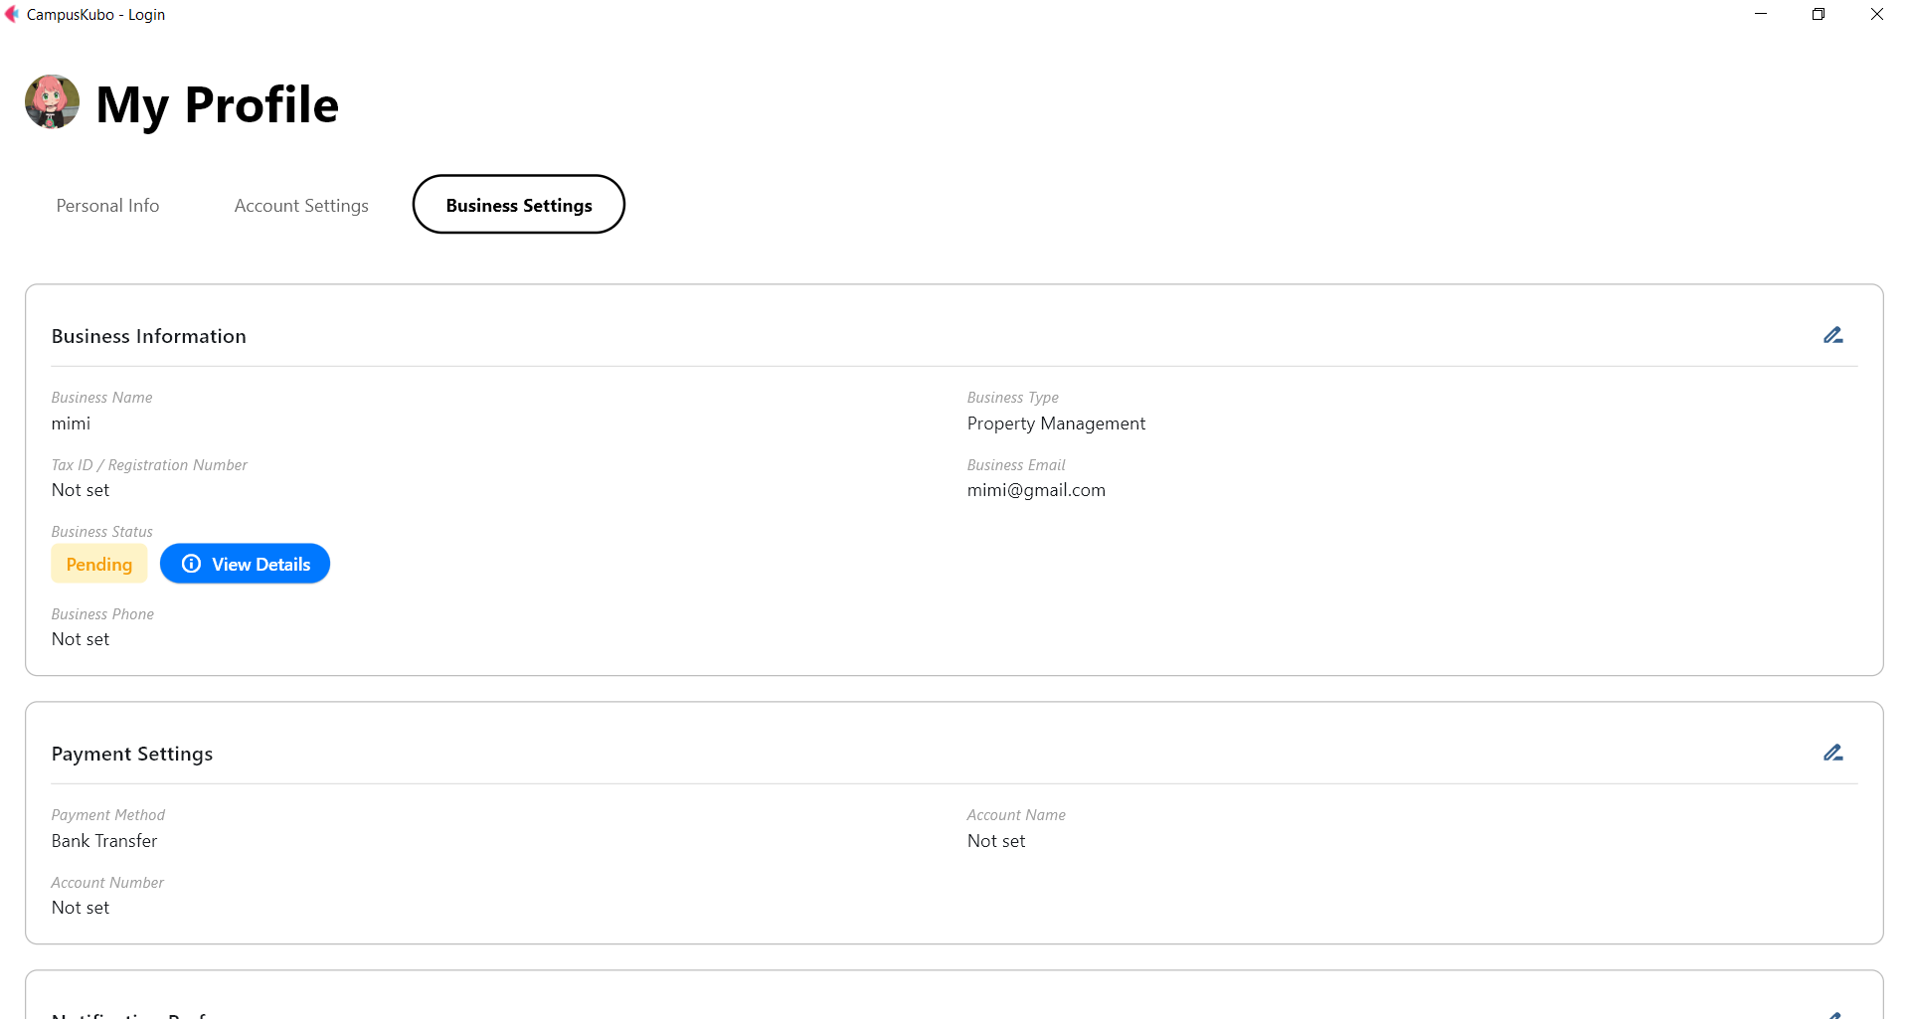

*Business information and preferences*

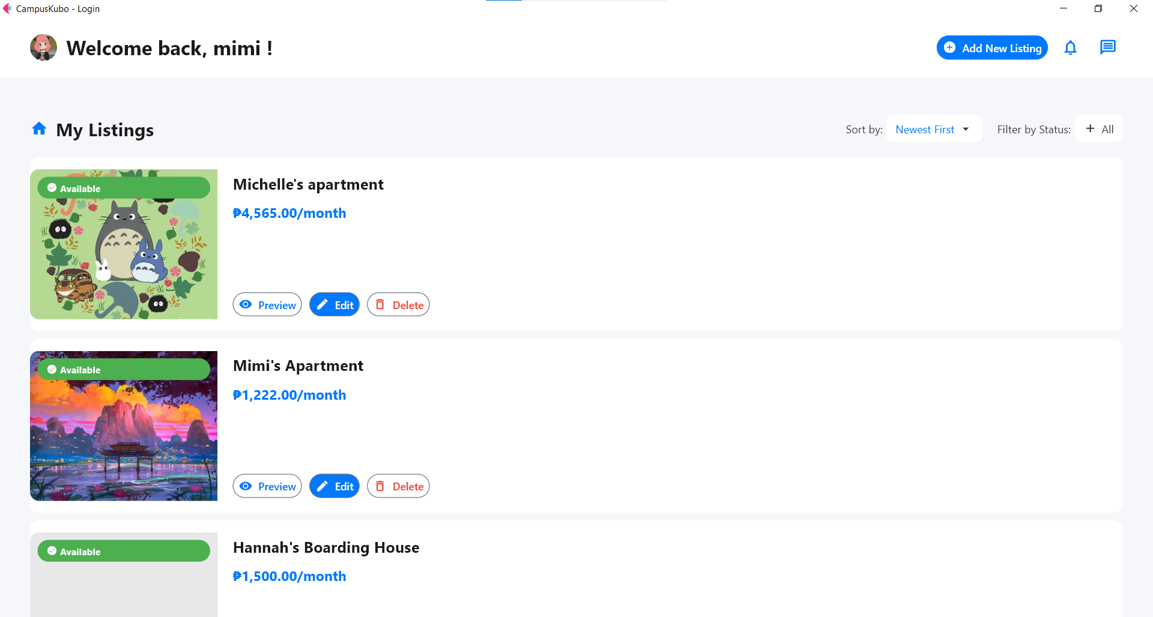

*Main dashboard*

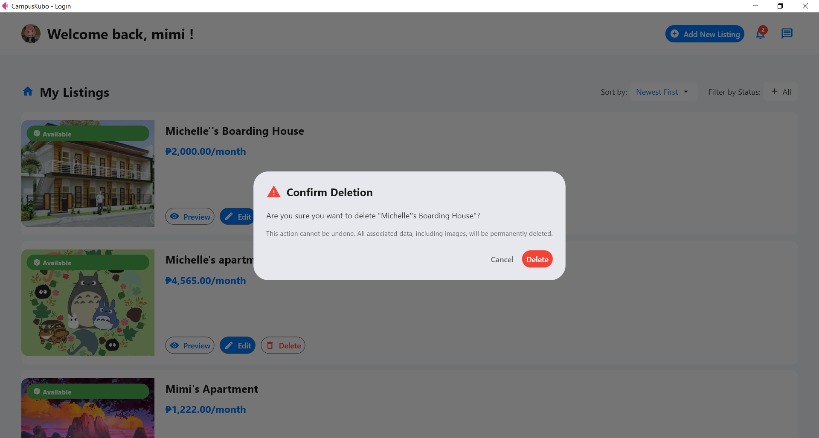

*Dashboard view showing the delete confirmation*

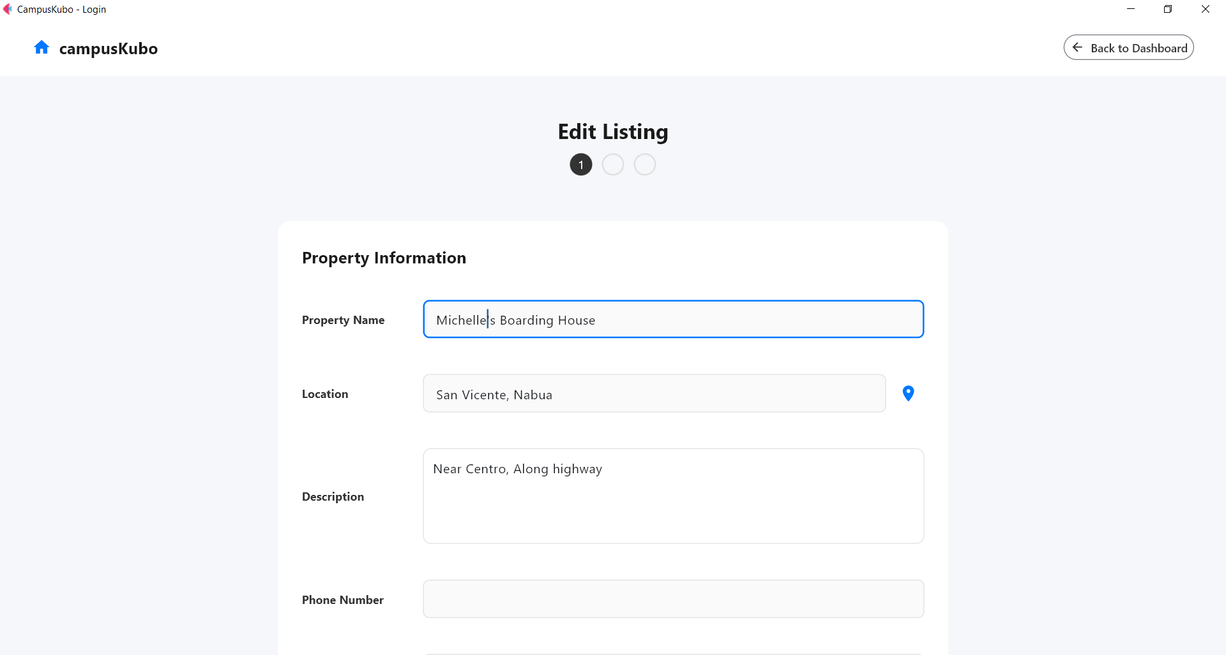

*Page where users can modify an existing property listing.*

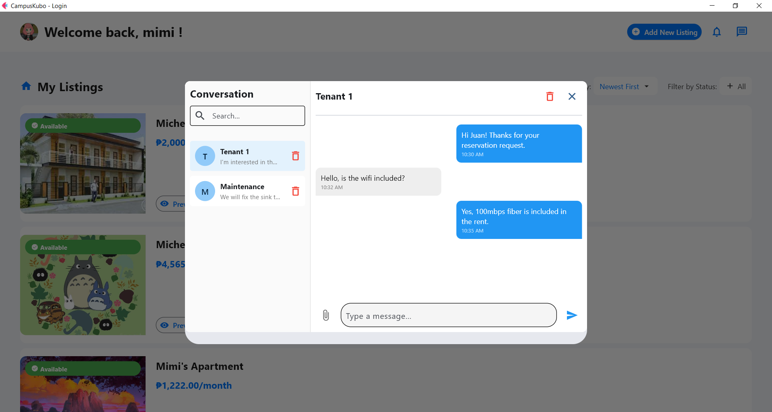

*Messaging interface for communicating with tenants or other users.*

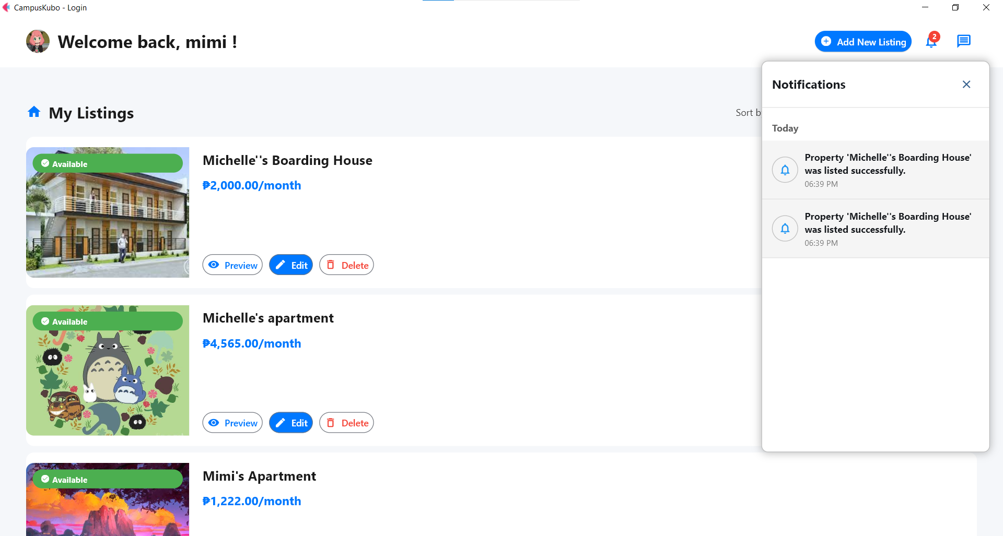

*Notification center showing system alerts, updates, and reminders.*

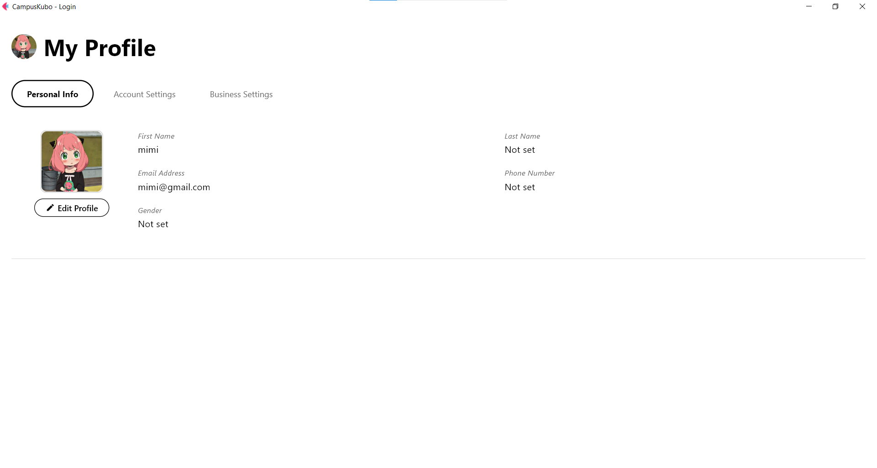

*User profile page displaying personal information*

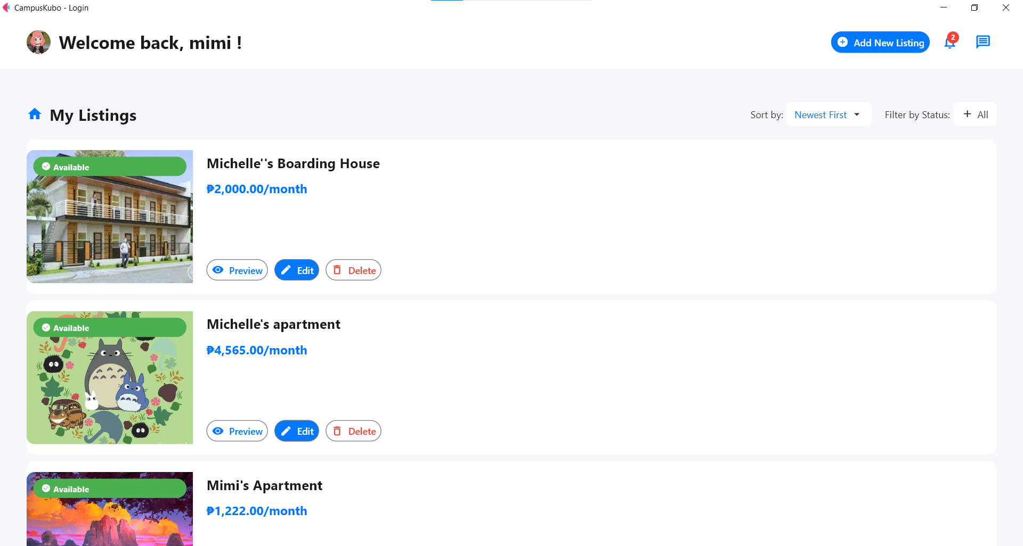

*List of all properties currently added*

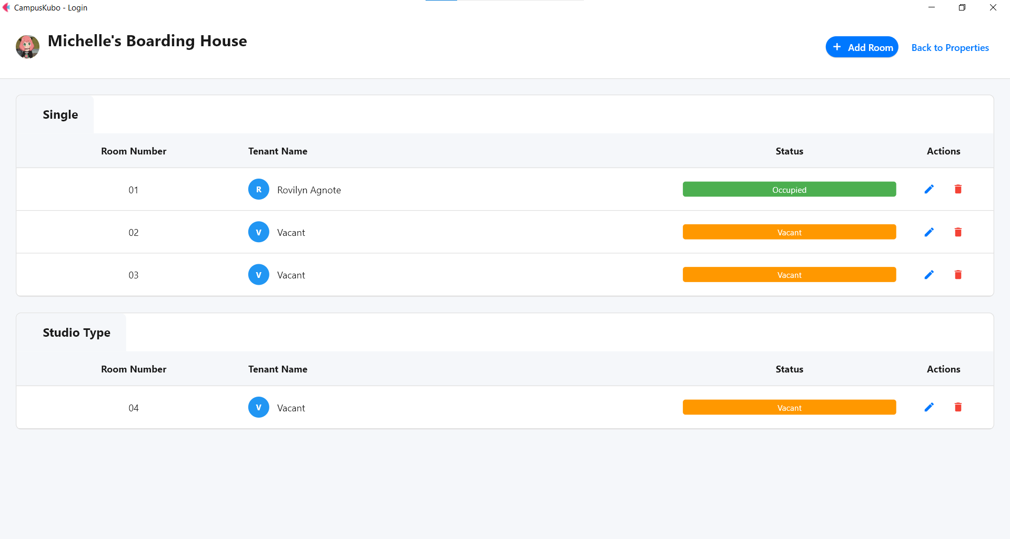

*Page for adding rooms to a property and configuring monitoring details.*

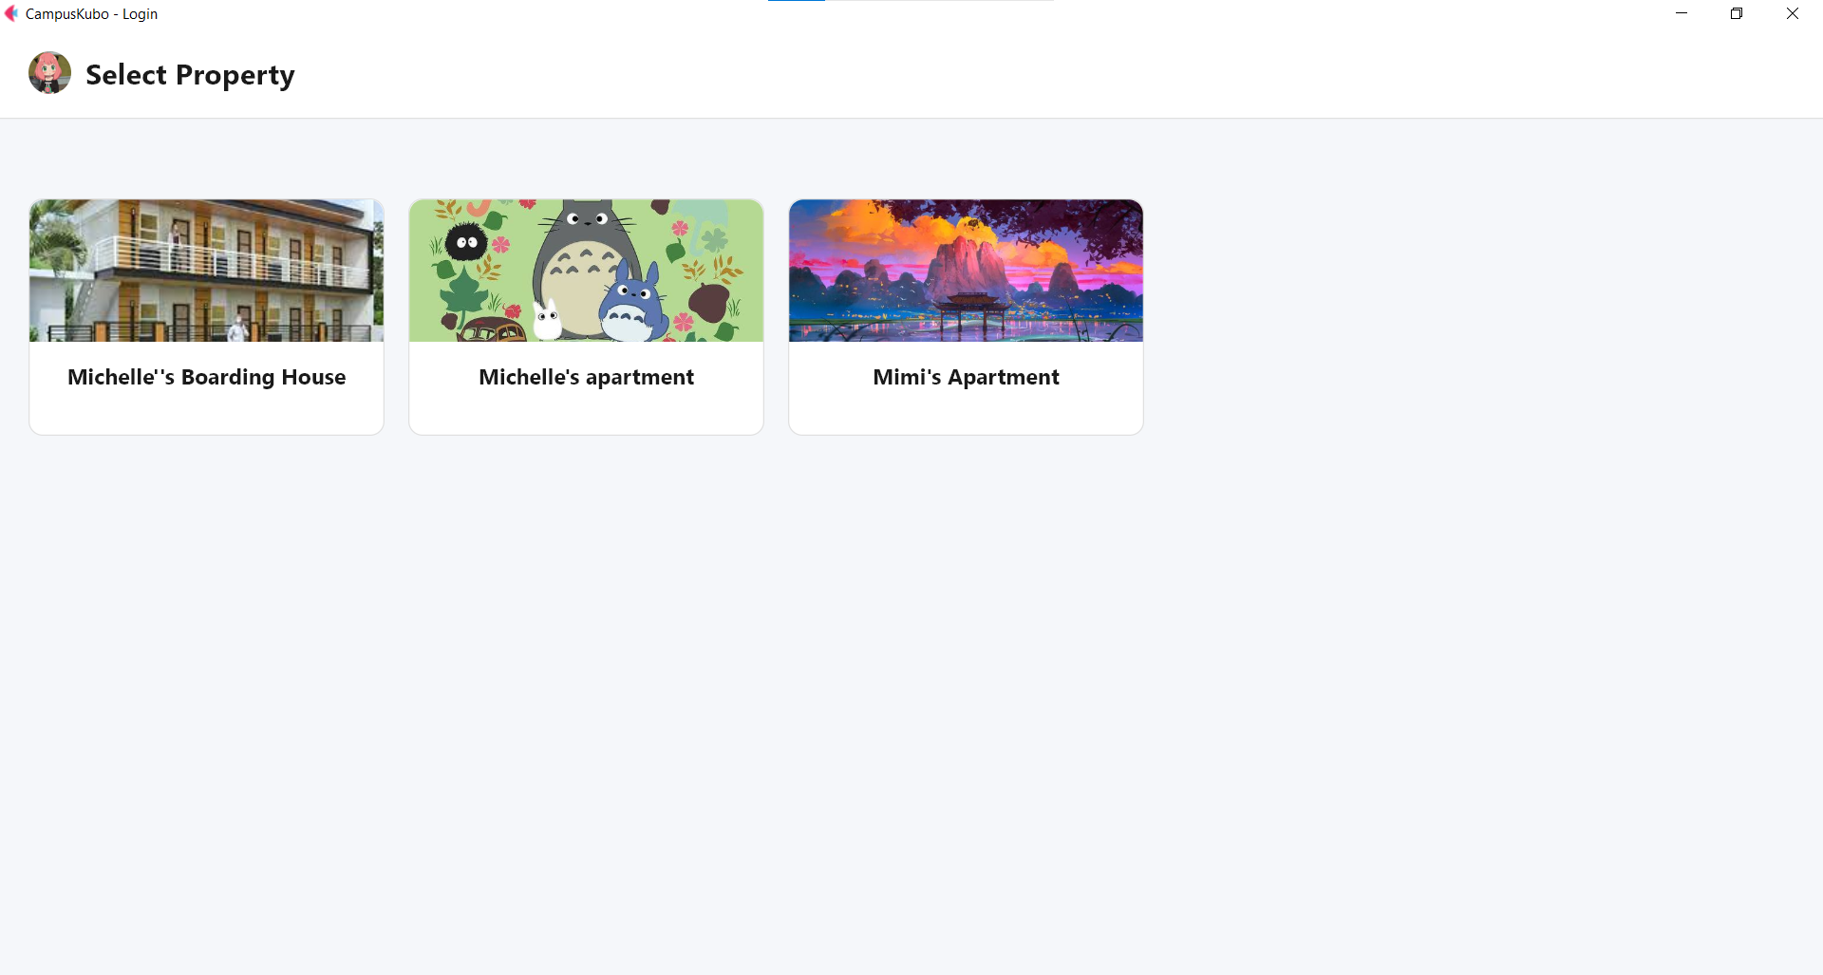

*Screen where users select a property before managing its rooms.*

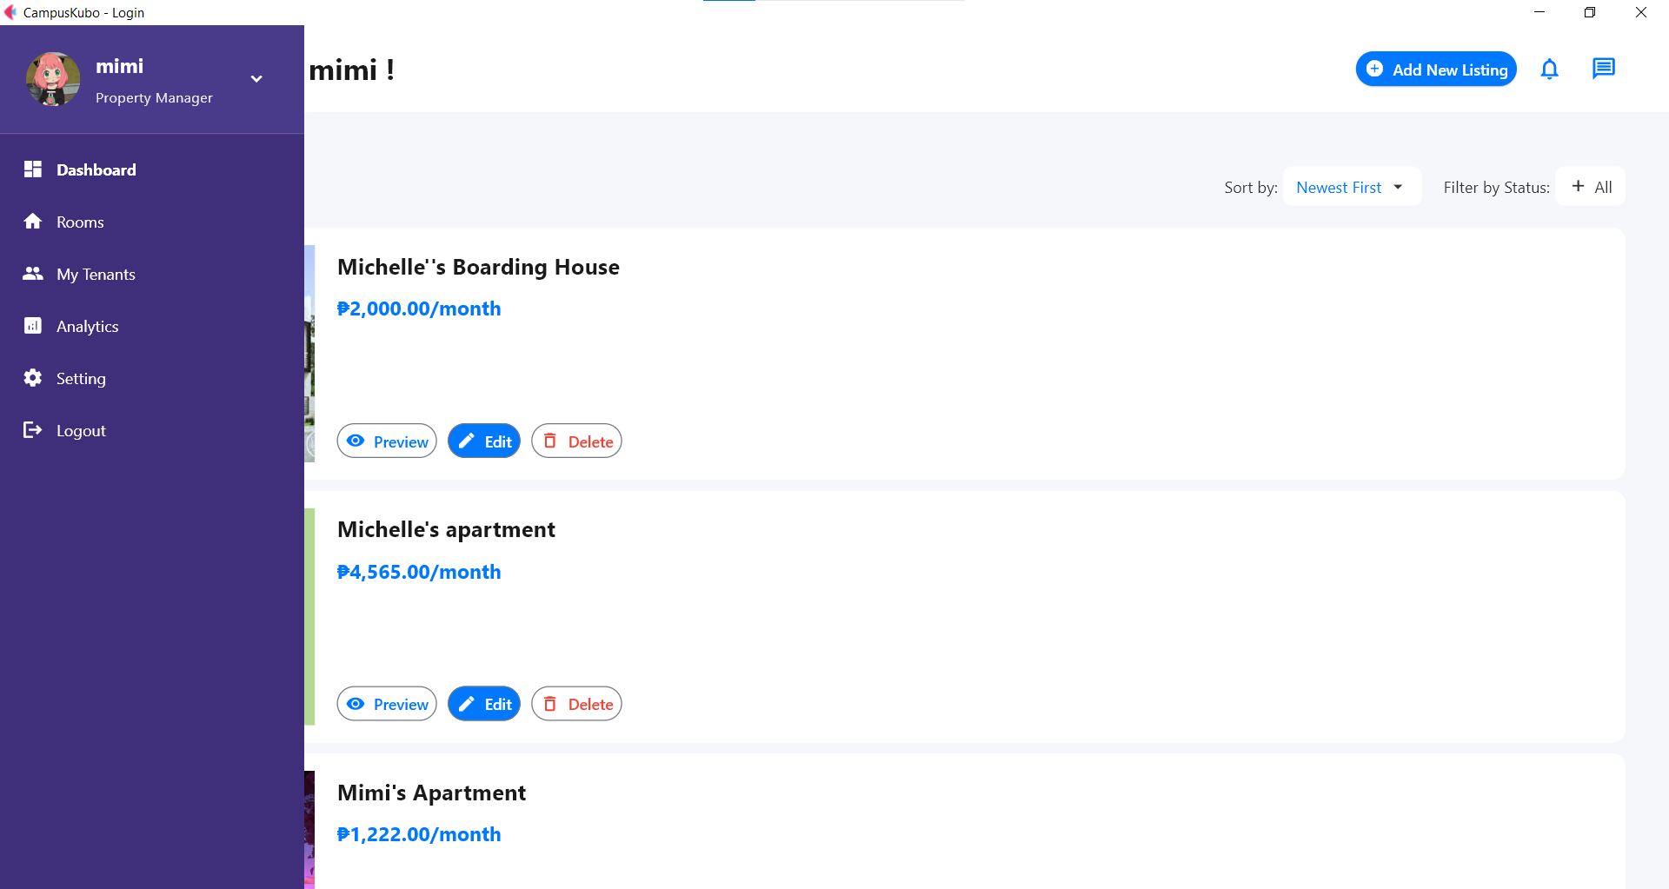

*Sidebar navigation menu showing available modules and quick links.*

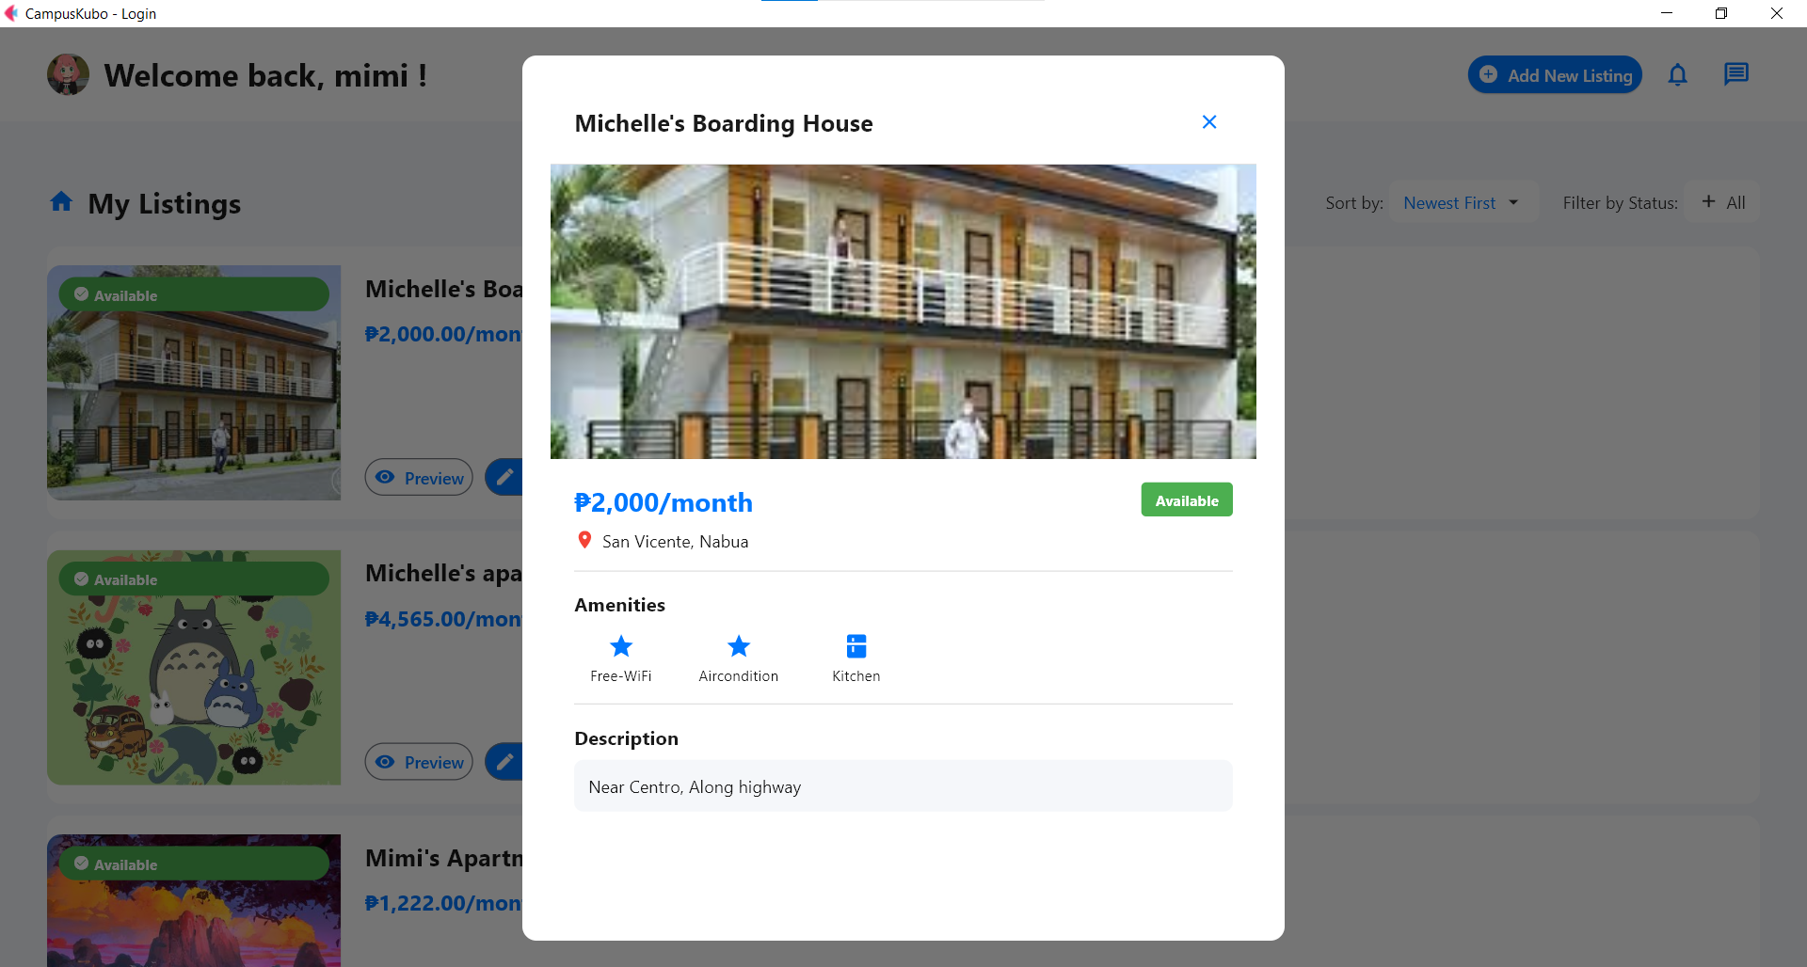

*Showing how a property listing will appear before publishing.*

1. **Tenant Dashboard**: (add description)

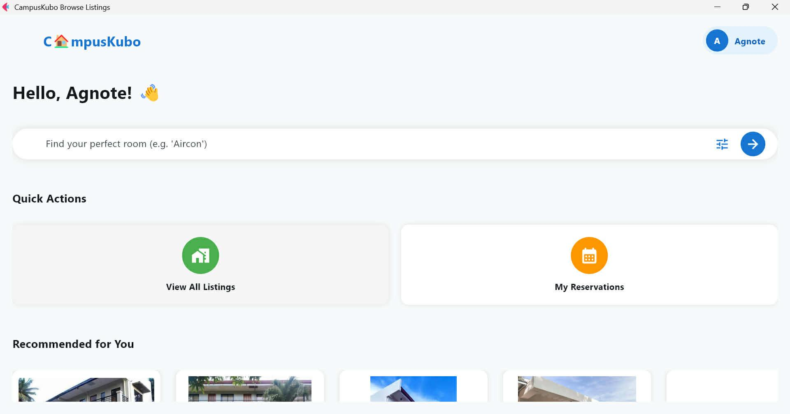

*Greets the user and provides quick access to listings, and reservations.*

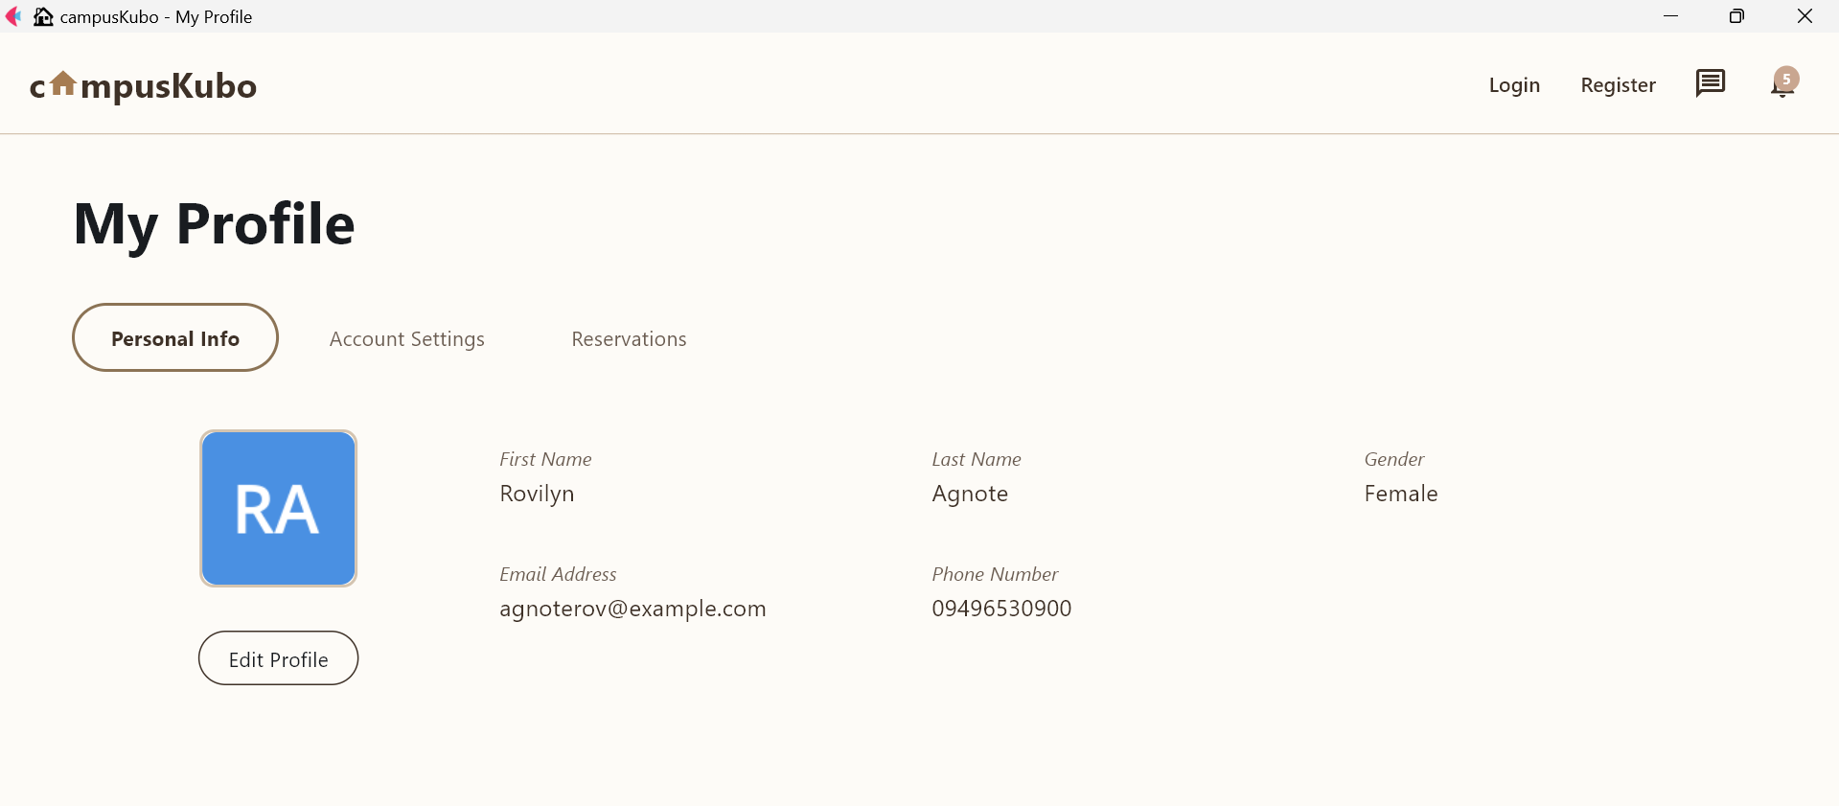

*Tenant’s personal info like name, email, and phone number.*

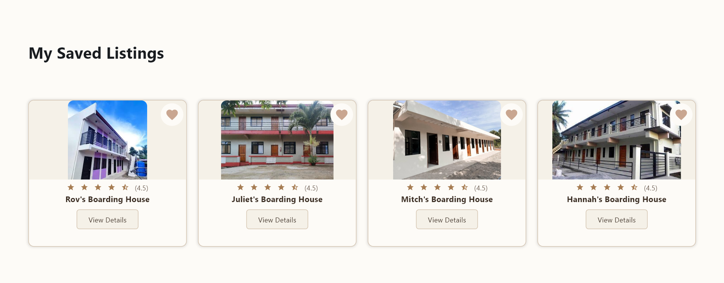

*Shows favorited boarding houses with ratings and view buttons.*

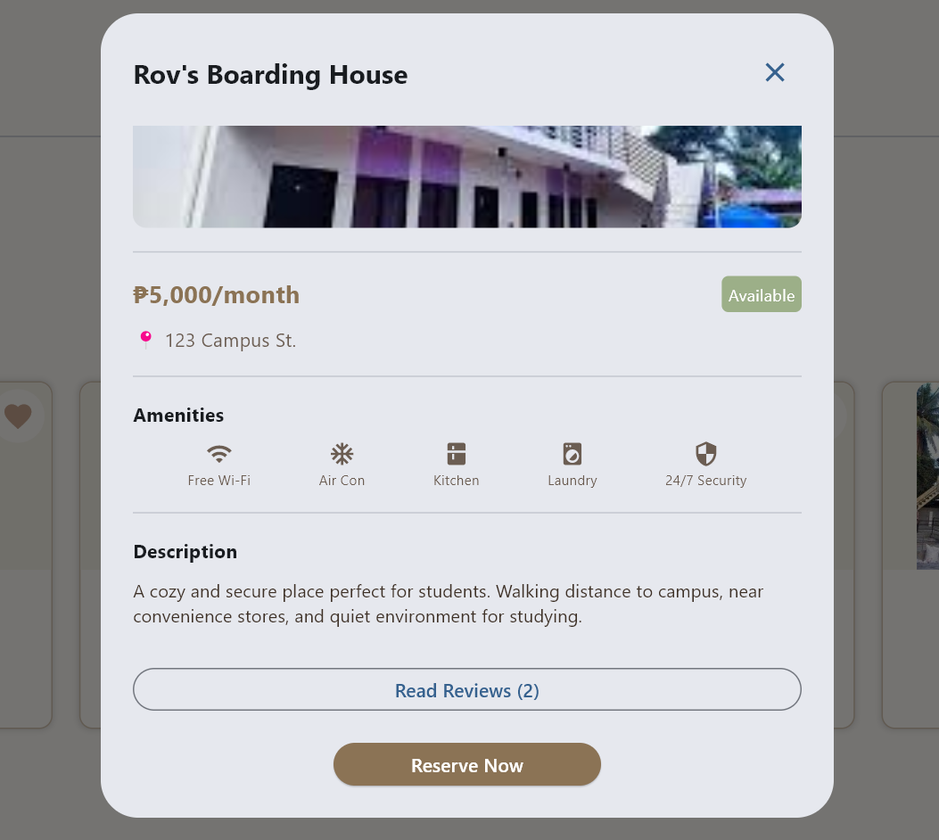

*Shows price, address, amenities, and description of a property.*

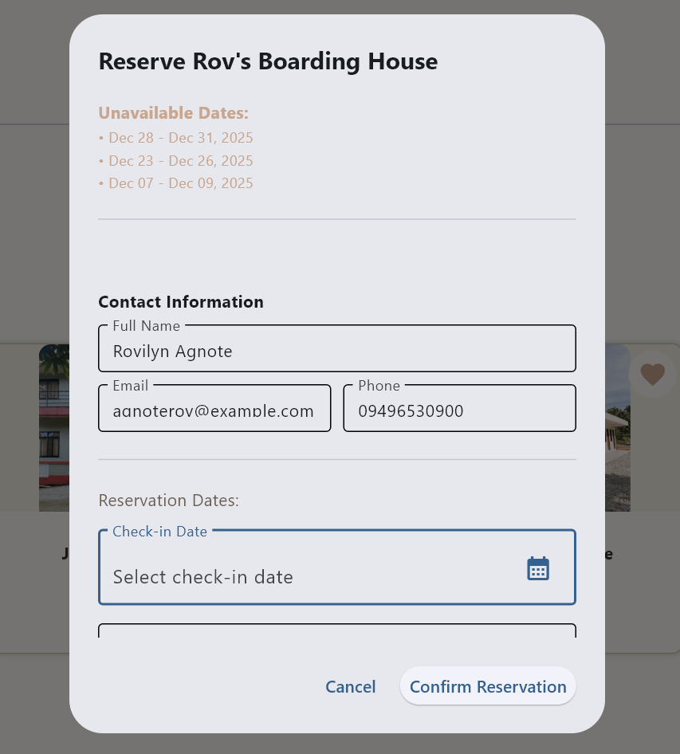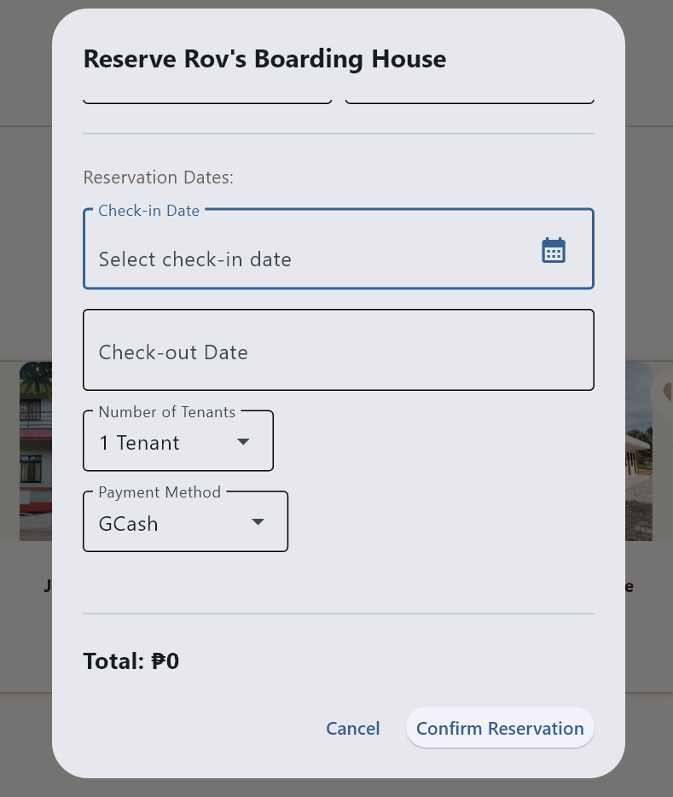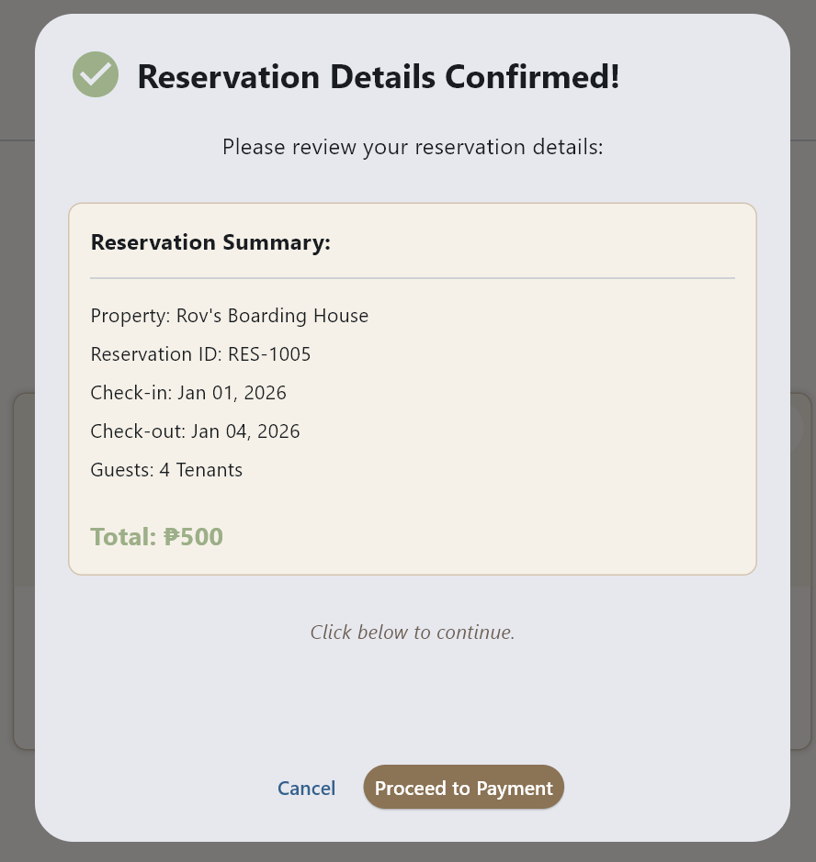

*Users can reserve a room by selecting dates, entering contact info, choosing tenants and payment method, then reviewing the booking summary.*

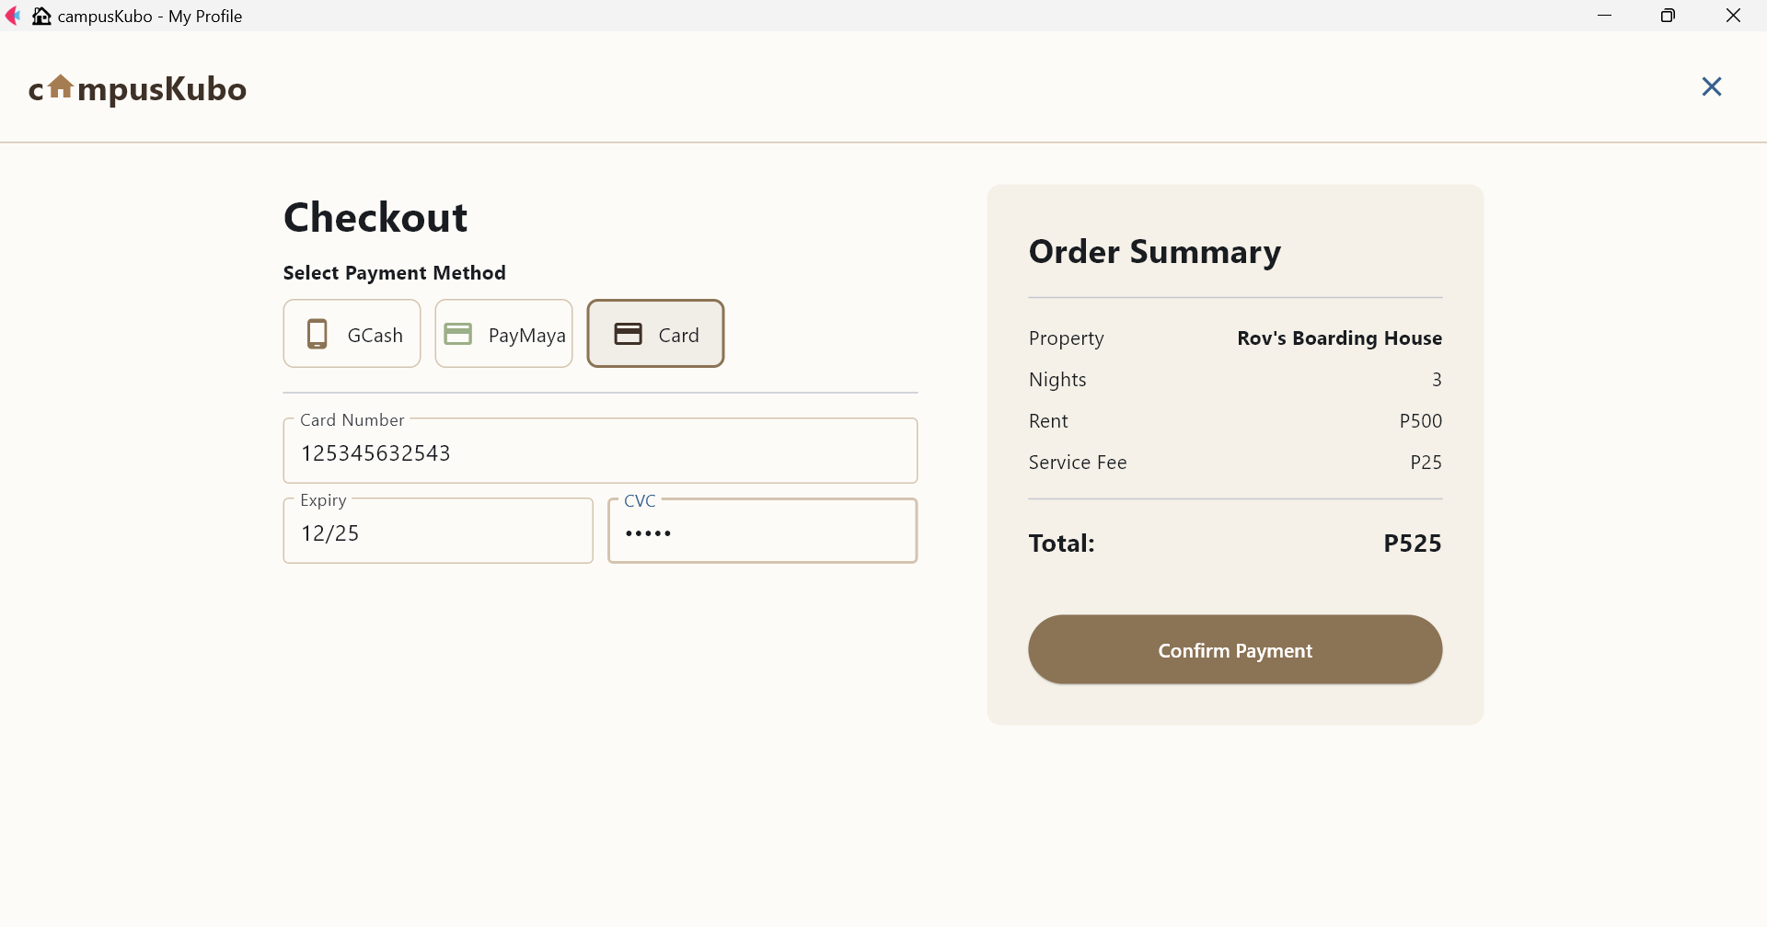

*Lets users select payment method and view order summary.*

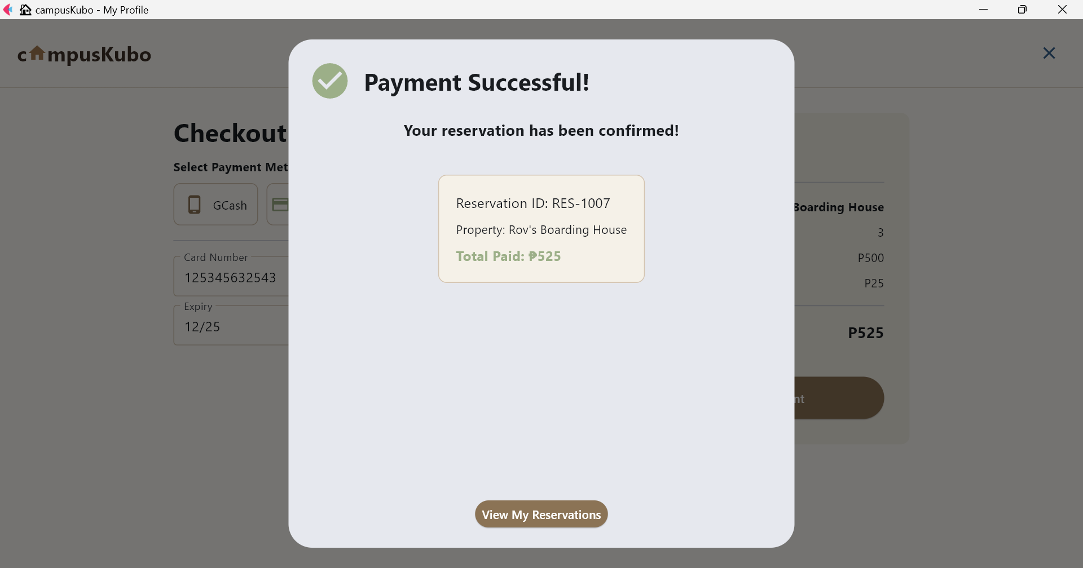

*Confirms successful payment and reservation details.*

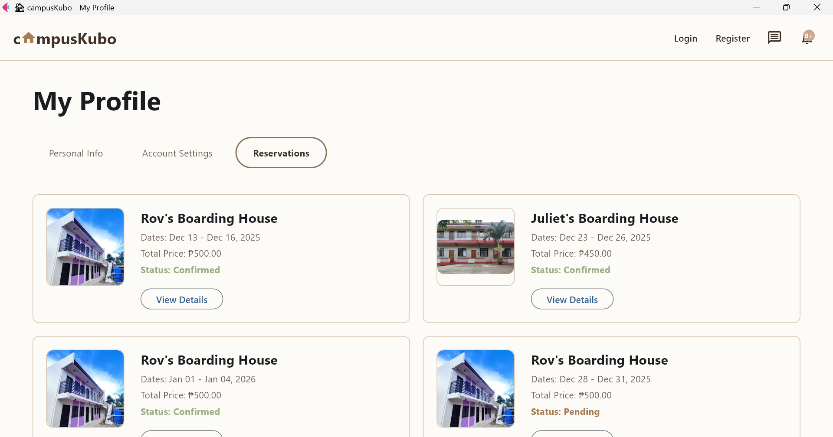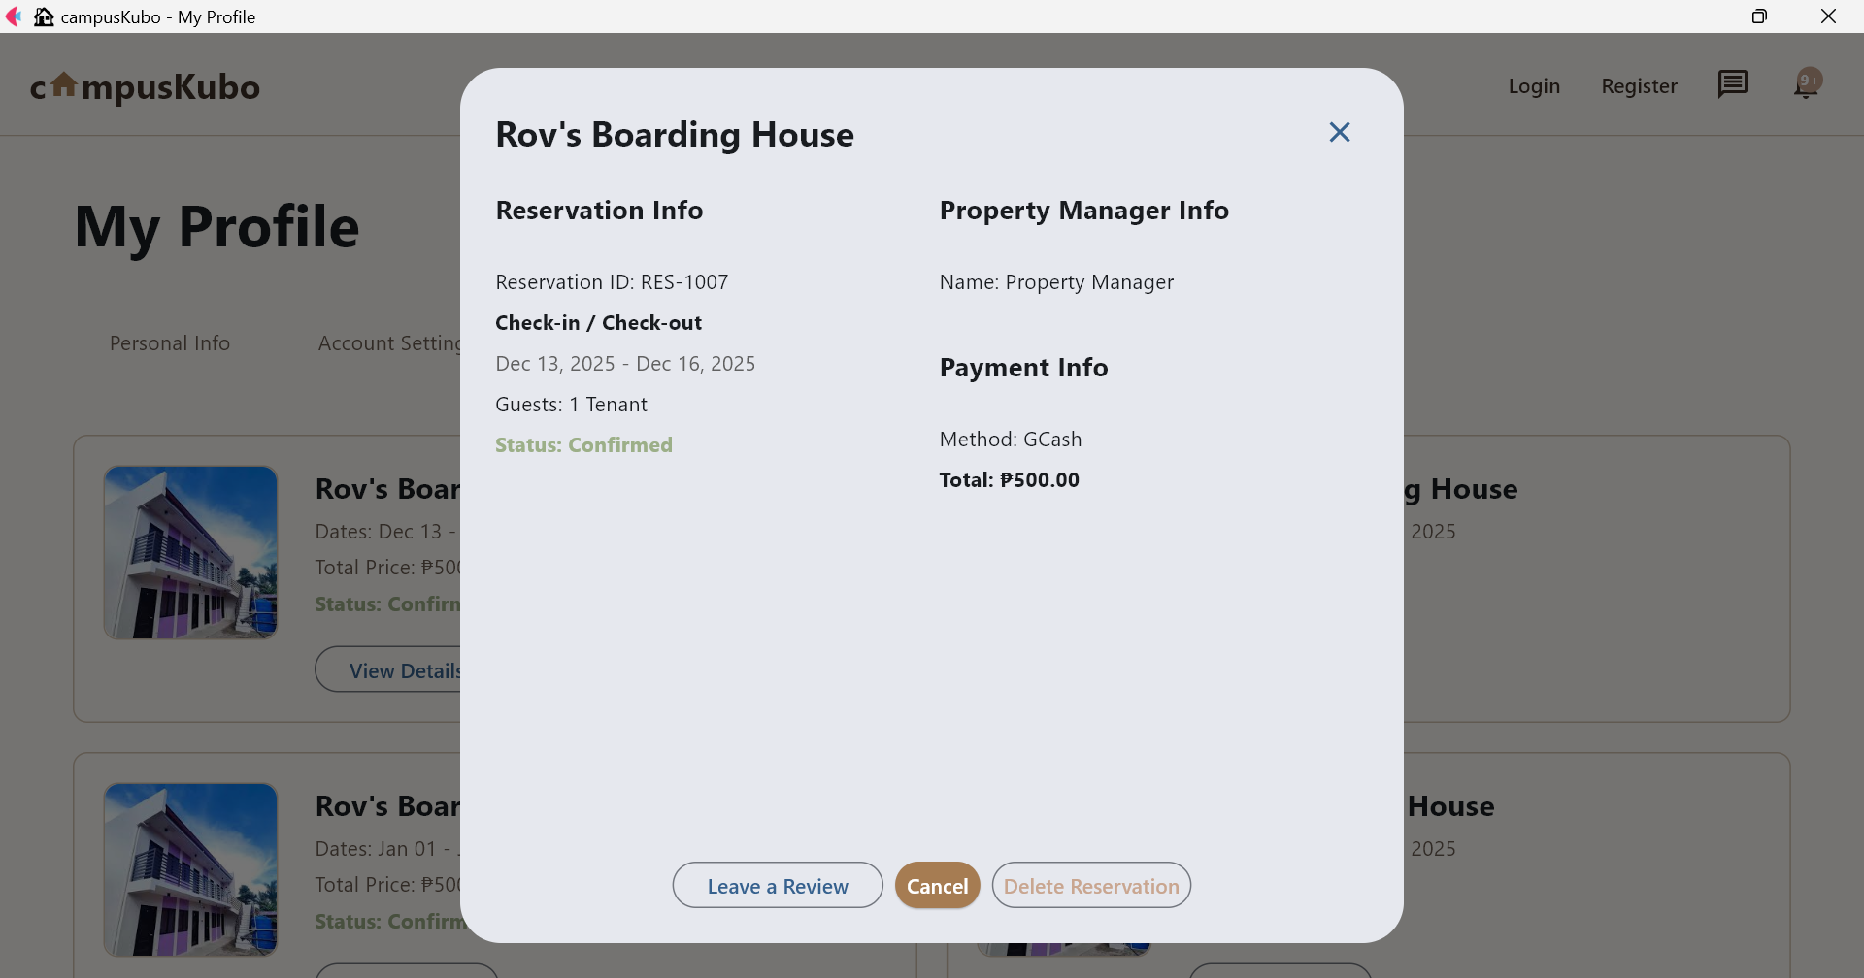

*It shows your past and upcoming bookings along with a popup that provides full reservation details, payment info, and manager contact.*

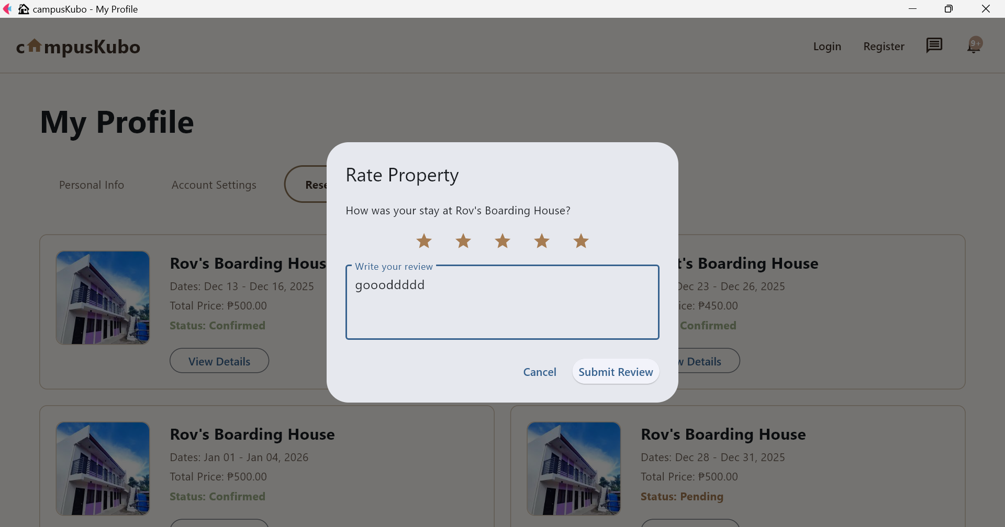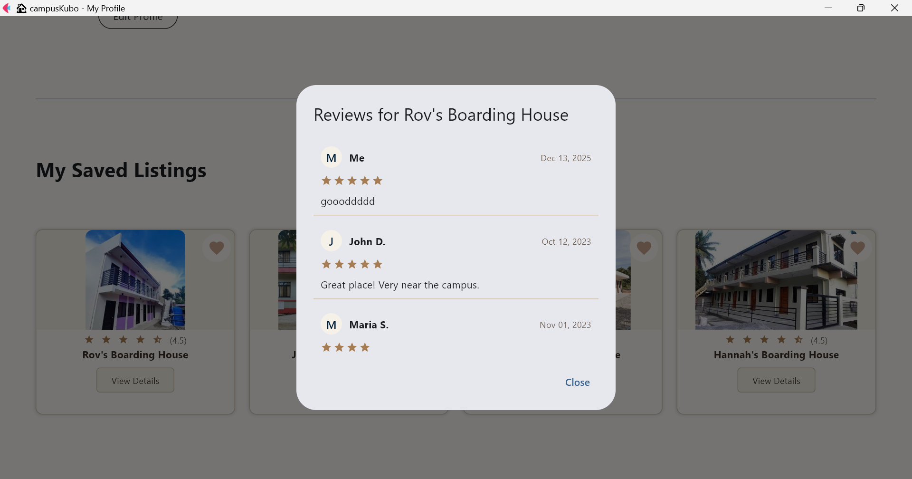

*Users can rate a property by giving stars and writing a review, and they can also view all reviews with ratings, names, and comments.*

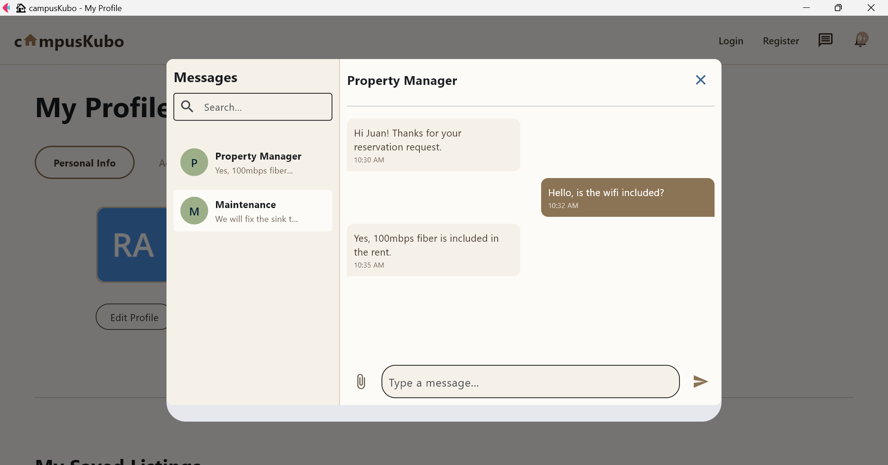

*Shows conversation between tenant and property manager about amenities.*

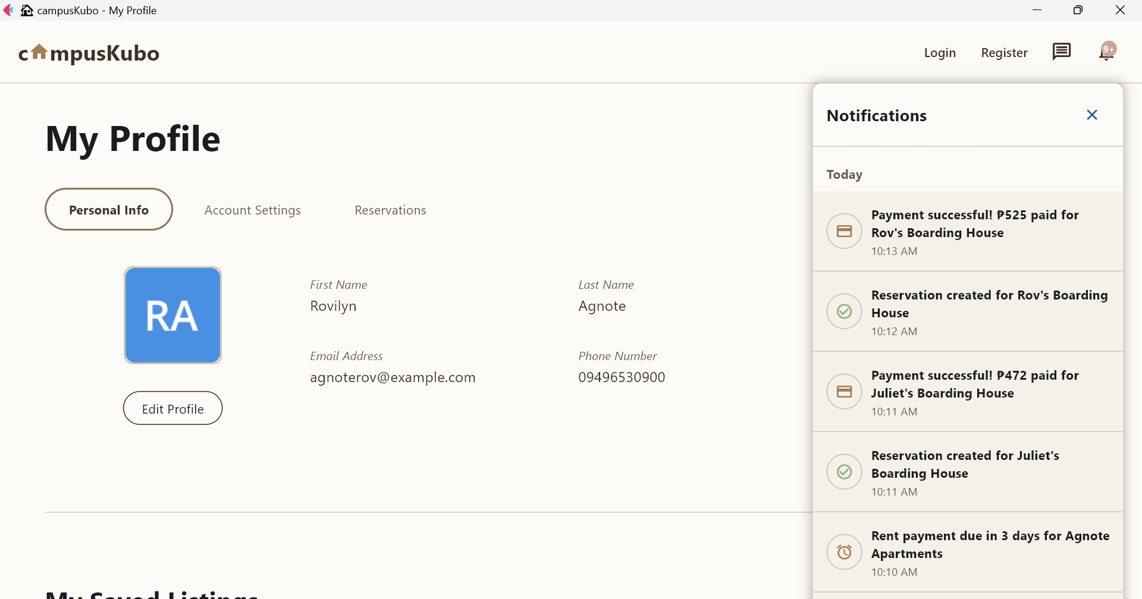

*Lists recent activity like payments, reservations, and rent reminders.*

1. **Troubleshooting**
2. **Common Issues**
3. **Application won't start**
   * Check Python version (3.8+)
   * Verify all dependencies are installed
   * Check database file exists
4. **Login issues**
   * Verify email and password
   * Check account is active
5. **Upload failures**
   * Check file size limits
   * Verify supported file types
   * Check upload directory permissions
6. **Payment issues**
   * Verify payment method details
   * Check internet connection
   * Contact support for failed transactions
7. **Support**

For technical support, contact:

* Documentation: Check the technical documentation
* GitHub Issues: Report bugs on the repository